Finals Paper Output for
CitiSense: A Smart Web App for Automated Multilingual Feedback Processing and Data Visualization

Project Documentation Submitted to the Faculty of the
School of Computing and Information Technologies
Asia Pacific College

In Partial Fulfillment of the Requirements for
Systems Analysis and Detailed Design MSYADD1

Submitted by:
Mark Lyster Marabi (Team Leader)
Lorenzo Emil Bernal (Member)
Gabrielle Cabangcala (Member)
Luis Lorenzo Lazaro (Member)
G07 QuadThink – SF 231

Submitted to:
Mr. Jose Euginio L. Quesada
Course Instructor

October 2025
1st Term
A.Y. 2025 – 2026

PM Docs Chapter 2
Project Charter
Project Name: CitiSense: A SMART Web Application for Automated Bilingual Feedback Processing and Data Visualization
Purpose
The purpose of the CitiSense project is to address the time-consuming, manual processing of feedback data currently handled by the IRAD department of the Department of Science and Technology – Science and Technology Information Institute (DOST–STII). The project responds to the growing need for automated sentiment analysis tools that support both English and Tagalog inputs, enabling faster, data-driven decisions. This initiative aligns with DOST-STII’s strategic goal to enhance public science communication and increase responsiveness to stakeholder feedback.
High-level project description
CitiSense is a web-based system that leverages Natural Language Processing (NLP) to automatically analyze and classify textual feedback in English, Tagalog, or a mix of both. The system processes sentiment as positive, neutral, or negative and presents the results in a real-time interactive dashboard. Key features include:
- NLP model for bilingual sentiment analysis (minimum 85% accuracy).
- Real-time data visualization through charts and keyword trends.
- Seamless integration with DOST–STII’s existing feedback collection systems.

High-level milestone schedule
The project has begun officially in July 2025, starting with the selection and initial fine-tuning of the Natural Language Processing (NLP) model tailored for bilingual sentiment analysis. In August, the development of the backend using Django will commence alongside the initial implementation of the frontend using React. By September, the team aims to complete a working prototype of the sentiment analysis system capable of processing and classifying feedback.
In October, efforts will shift toward integrating a data visualization dashboard that will display sentiment trends and keyword insights in real time. November will be dedicated to system testing using actual feedback data from the IRAD department, ensuring that the application meets performance and usability expectations. During December, final enhancements, usability improvements, and interface refinements will be applied based on testing feedback.
The project will conclude in January of 2026, with the full deployment of the CitiSense system and formal turnover to the IRAD department of DOST–STII for integration into their operations.

Rough cost estimate and budget
Estimated Budget: PHP 0 (Open-source development)
Cost Breakdown:
- NLP Model: Free (HuggingFace open-source models)
- Backend: Django (open-source)
- Frontend: React (open-source)
- Database: MySQL (open-source)
- Hosting: Free tier services (Vercel for frontend, Render/AWS for backend)
Funding Sources:
- DOST-STII support (non-monetary, testing data and validation)
- Team resources (QuadThink student-led development)

Stakeholders
Primary Stakeholder:
- IRAD Department, DOST-STII – End users and beneficiaries
Other Stakeholders:
- Researchers and Data Analysts at DOST
- Other Government Agencies with similar feedback systems
- Future Project Developers
- Educational Institutions (for research and learning applications)

Project manager
Name: Mark Marabi
Position: Project Lead, QuadThink Team
Project manager’s responsibilities
- Oversee the full development lifecycle
- Ensure adherence to the timeline and deliverables
- Manage collaboration with IRAD stakeholders
- Facilitate testing, documentation, and deployment
- Report regularly on progress and challenges

Project manager’s authority
- Coordinate team assignments and workload
- Make technical decisions regarding design and implementation
- Resolve conflicts within the development team
- Communicate directly with stakeholders for feedback and validation
- Approve sprint outputs and initiate changes as needed

Formal declaration of sponsor’s support
Name: Arjay Escondo
Position: Division Head, IRAD – DOST-STII
Authority: Project sponsor and approving authority on behalf of DOST-STII
Sponsor Statement of Support:
“As the sponsor of the CitiSense project, I fully endorse its development and implementation to enhance the feedback analysis capabilities of the IRAD department. I recognize the value of automating sentiment classification and visualization for better decision-making and institutional responsiveness. I am committed to supporting the QuadThink team in developing a solution aligned with DOST-STII’s mission.”

Project Objectives
Objective | Category | Measure
Develop a web application that uses Natural Language Processing (NLP) | System Development | CitiSense web application deployed with NLP sentiment analysis with visualization features
Accurately classify survey responses (positive, neutral, negative) in English and Tagalog | Quality | Achieve ≥ 85% accuracy within a 6-month development timeline
Automate feedback processing to  reduce manual workload | Efficiency | Reduce workload by ≥ 80% and accelerate report turnaround time
Ensure timely, data-driven decision-making within DOST-STII’s IRAD department | Information Responsiveness | Feedback reports generated in real-time
Support English, Tagalog, and code-switched input in sentiment classification | Technical | Bilingual model with ≥ 85% classification accuracy

Project Scope
Project goal and objectives
CitiSense is a web-based application that will supplement the current system of CitiSense with a means to automatically analyse and display sentiments in English, Tagalog, or multilingual survey answers using Natural Language Processing (NLP). Its key objective is to categorize the feedback as positive, neutral, and negative as accurately as possible, with an accuracy not lower than 85 percent per six months. The automated process shall save 80 percent of the manual workload, which will improve the turnaround time for feedback reports in order to make quick, responsive decisions. CitiSense is also designed to integrate easily with current workflows and future scalability (e.g., the addition of new languages and new data sources).
Project Boundaries
Within scope: In this project, the objective is the development of CitiSense, a web application that will make an automatic analysis of feelings and see figures presented in questionnaire answers in English or Tagalog, or a combination of both languages. A properly tuned Natural Language Processing (NLP) model will be used in the system. Subjecting feedback to three categories: that is, positive, neutral, and negative. Also, it will include a dynamically updated dashboard complete with sentiment trends and keywords, aiding the IRAD division of DOST to be more enlightened about what people feel. It will be an app. To be integrated with the already existing feedback collection form used by DOST-STII, and will be able to receive text-based feedback. The main audiences of this system are data analysts, data researchers, and government officials following up on the reactions of the people.
Out of scope: Audio and visual responses will not be supported, and the system will only support text responses. Although the model of NLP is made to deal with both Tagalog and English inputs, when dealing with regional languages, it is better to use regional languages. Very informal language or dialects may affect the precision of sentiment classification. The performance of this model is influenced by the training data used, as it has to depend on its quality and diversity. Furthermore, the visualization segment will be reduced only to the sentiment patterns and keywords; more sophisticated Predictive analytics or topic modeling will also not be added in this first release. Moreover, they will not incorporate real-time data from any external sources into the current feedback system. form
Project Deliverables
- Text Only NLP Feedback System: A Web application that feeds back and parses feedback containing either English or Tagalog input or both in any permutation with the 3 possible sentiment conditions (Positive, Negative, or Neutral).
- Sentiment Visualization Dashboard: A simplified dashboard of:
- Trends in sentiment or by category
- There were highlighted keywords indicating themes of feedback
- Language Model (NLP engine) The Language Model is an NLP model trained to work with English and Tagalog input (to some extent, the input of informal or dialectal words).
- Feedback Processing Pipeline - Backend infrastructure that ingests the feedback data and generates structured sentiment classes.
- Static Dataset Integration - A system that uses preloaded/static feedback data (not live online or other live systems).
- Documentation-User Guides, model restrictions, and documentation of use and feedback management in the system.
Success Criteria
The project and its deliverables will be deemed completed when the NLP model categorizes the feedback on English and Tagalog correctly, and the sentiment visualization dashboard will show noticeable trends and meaningful terms. It should not be underdeveloped in functionality, free of bugs, and be able to process static feedback information and meet the desired level of performance without depending on external sources in real-time.
Passing through User Acceptance Testing (UAT), stakeholder approval, and provision of complete documentation are also determinants of success. After the system is deployed, tested, and officially delivered to IRAD with relevant training and sign-off, the project may be considered complete
Project Assumptions
- The security and privacy are already operational in the DOSTSTII to manage user information.
- DOSTSTII already has security and privacy policies in place so that it can deal with the data of the users.
- The training data on which the NLP model is trained has the quality and quantity needed to give decent accuracy on the sentiment classification.
Project Constraints
Time Constriction has to be done within a strict timeframe, including development, testing, and releasing, which reduces the number of features and possible fixes that can be incorporated into it.
Data Constraint – The effectiveness of the model is bound to available training data, whose quality and variety can impact the overall system accuracy.
Technical Limitations- There will be no connection to live external sources or APIs, and the system will handle only static (uploaded) data.

Stakeholder Analysis
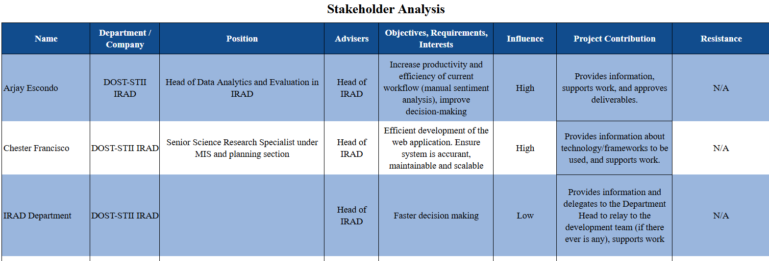

OpenProject Activities
INITIAL BUDGETS
1 – Initiation Phase
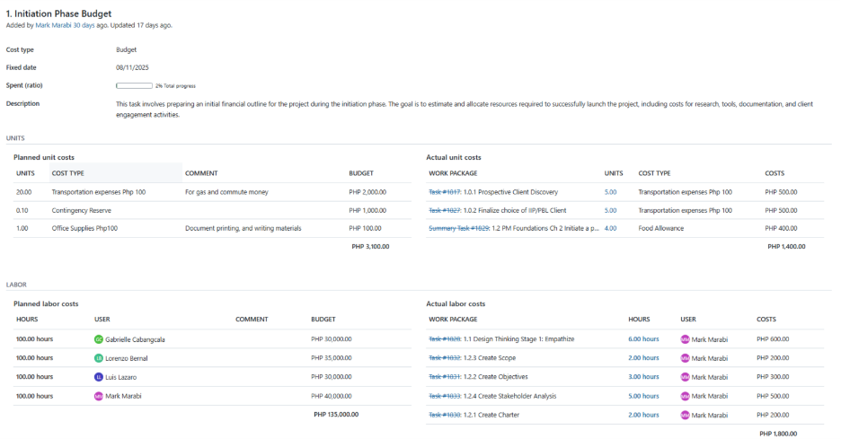

2 – Planning Phase
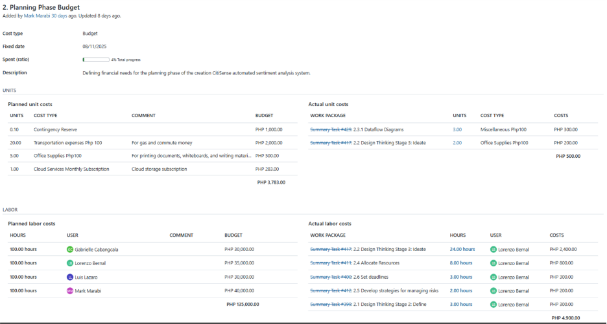
ROADMAP
1 – Project Setup and Direction
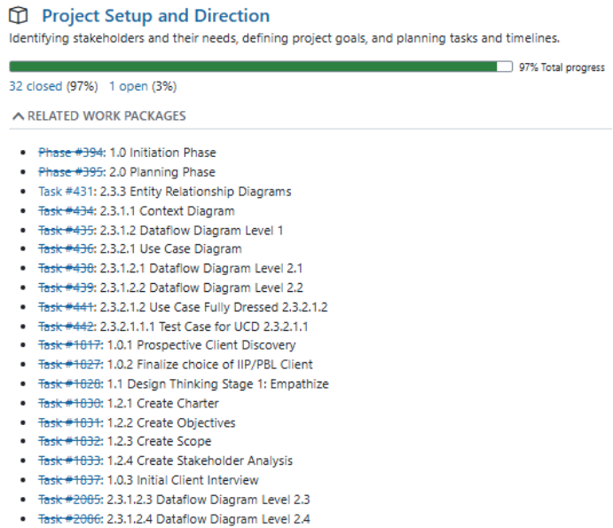
2 – Development and Delivery Phase
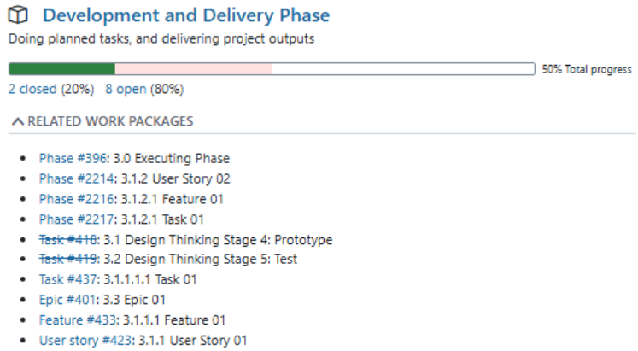
3 – Managing Progress
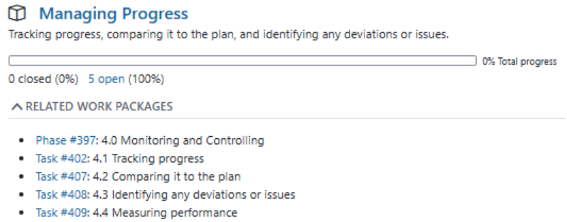
4 – Finalization Phase
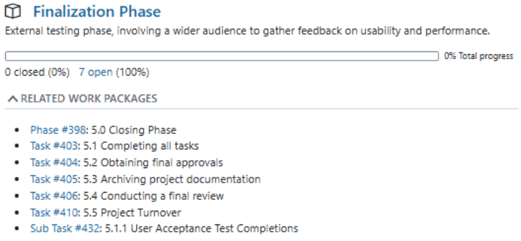

WORK PACKAGE
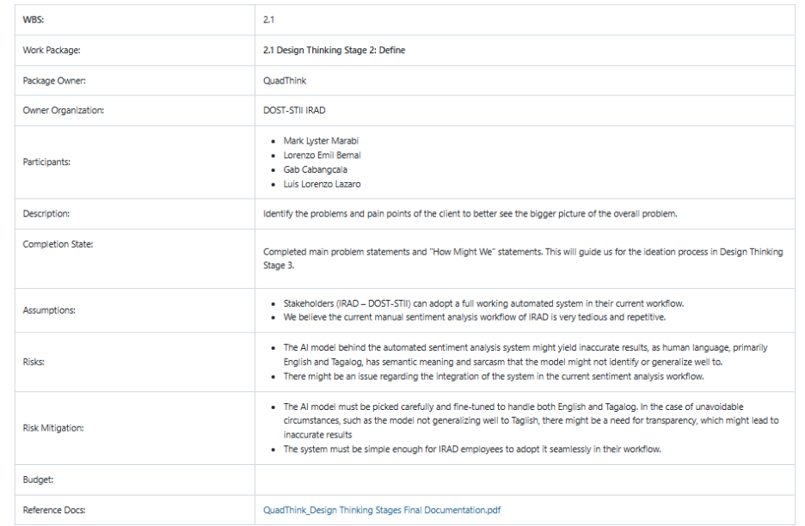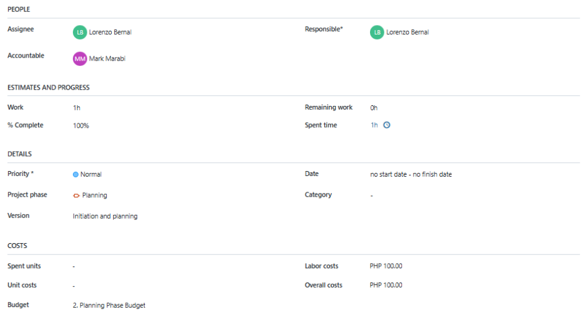

BOARDS
1 – Initiation Phase
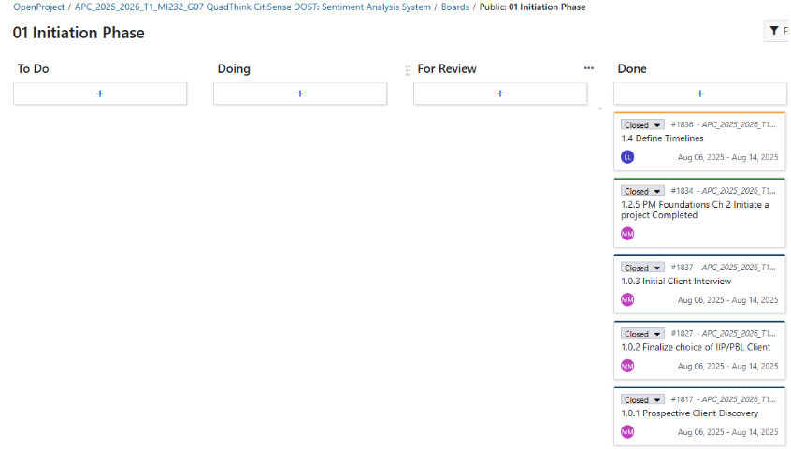
2 – Planning Phase
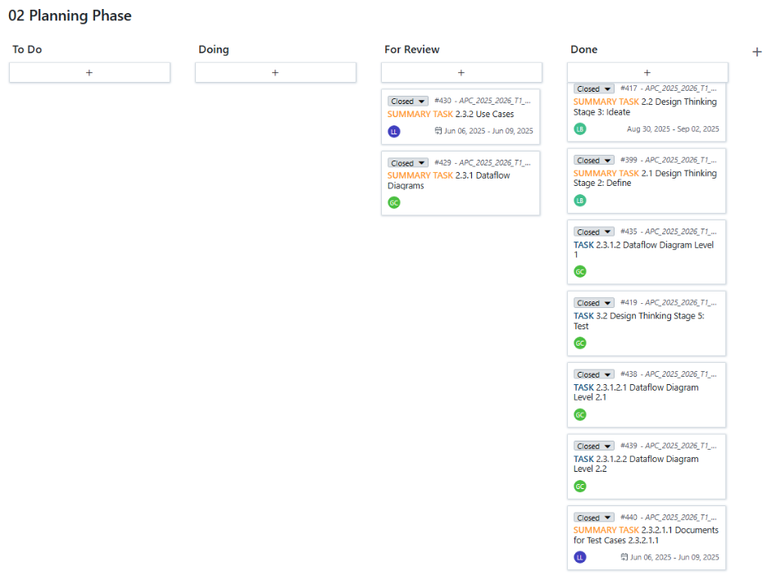

OpenProject Updates
Initiation Phase Budget
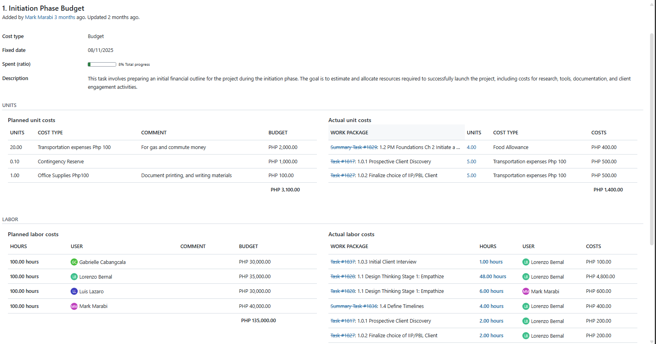
Planning Phase Budget
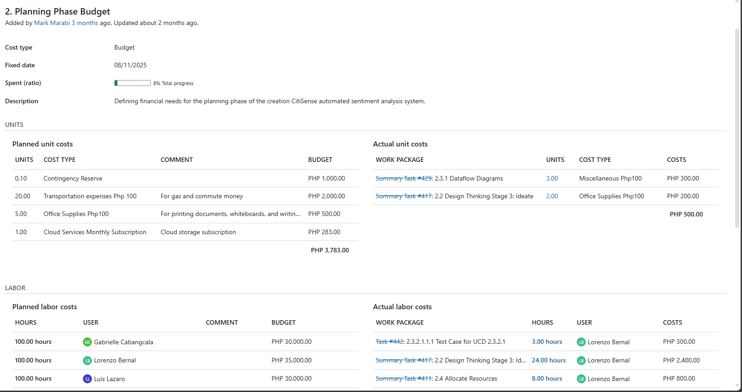
Roadmap
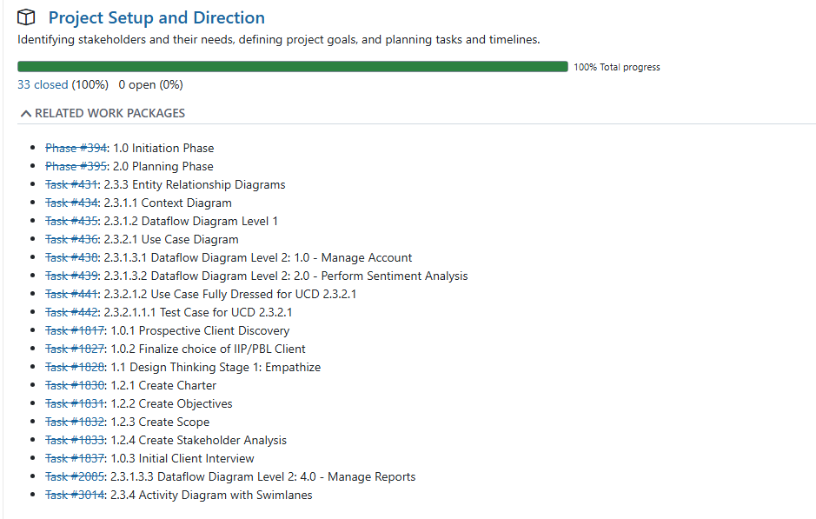

New and Unassigned Work Packages
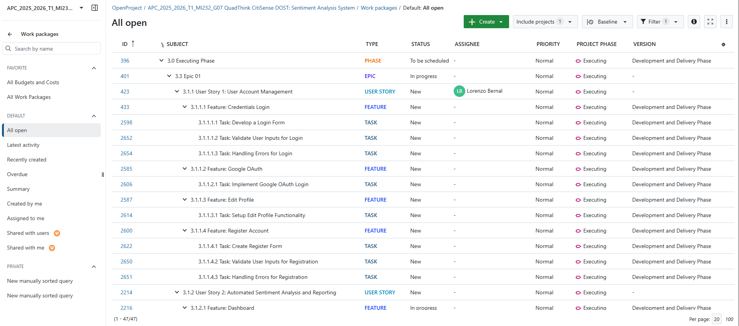

Backlogs
- These are the prioritized features that need to be completed.
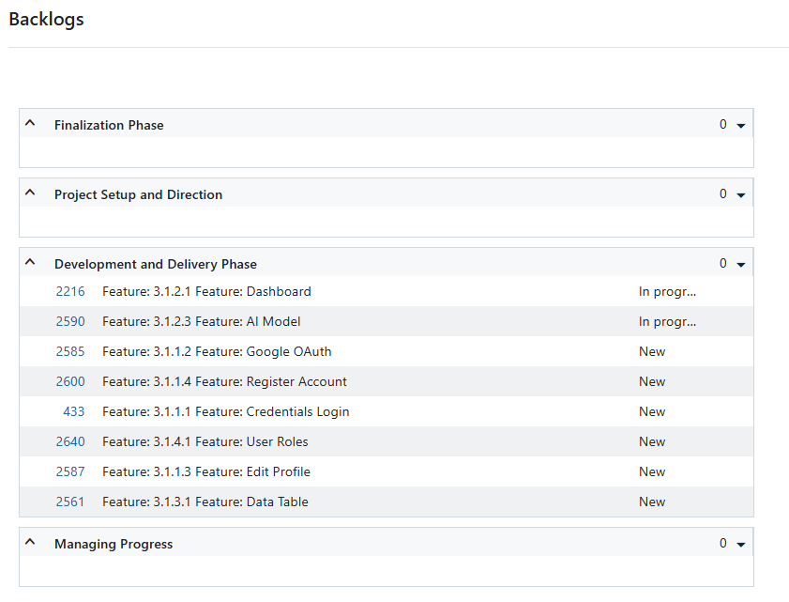

AY 2025-2026 T1 Sprint 01 Board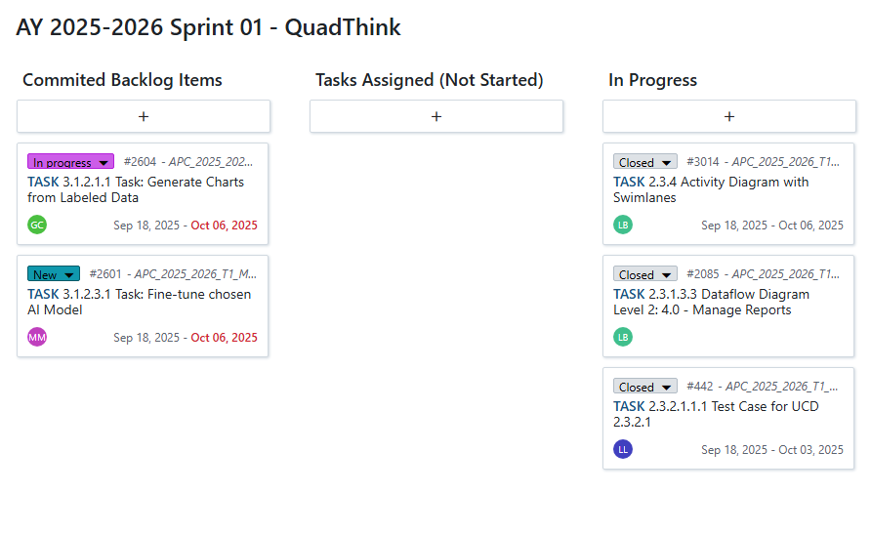

- 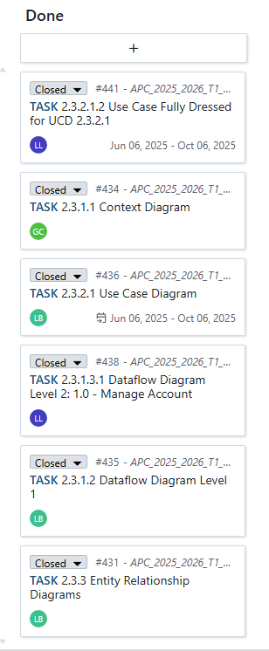

Gantt Chart
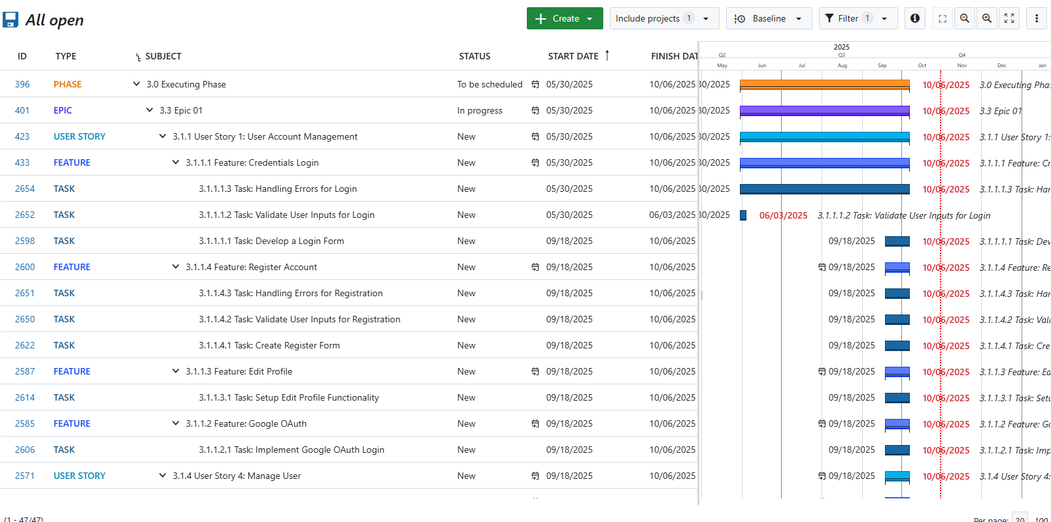

Design Thinking Stages
Stage 1: Empathize
Introduction
In the first stage of Design Thinking, our group, QuadThink, aims to achieve the goal of gaining a deeper understanding of the needs, wants, and circumstances of our client, together with the customers. In order to achieve this goal, our group conducted several online interviews via Zoom together with our client and the IRAD (Information Resource and Analysis Division) department of DOST-STII (Science and Technology Information Institute). This allowed us to directly gather relevant ideas even though we are not physically present in various meetings.
Whenever our group meets with the client and customers, we ensure that we gather correct and accurate information regarding their concerns and perspectives to provide a suitable solution for their challenges. Our group made use of various guidelines that were presented during class discussions in order to stay right on track. Moreover, our group made use of the 5 Whys to dig into the main cause of the problem. In addition, our group also asked open-ended questions to gather more relevant information about the problem, as well as to document the client and customers' detailed and authentic responses. The recorded sessions have helped our group to create customer personas that match the perspectives of the customers involved in order to visualize and organize the information gathered. Lastly, our group made an empathy map and pain-gain analysis to recognize their behaviors, feelings, and pinpoint their frustrations and opportunities for development.
With the help of these activities, our group was able to better understand the issues and problems of the IRAD department and to prepare for addressing all of their needs in the next steps of the design thinking process.

Interview with the Client
(5 whys):
- Why is the sharing of ideas across teams challenging with your current system?

- “We don’t have a system.”

- Why don’t you have a system?

  - “Well, new, di sya new pero how can I say it, it's not common for government agencies to analyze sentiments or ung comments. It's not common for agencies to analyze deeply ung mga text data.”

- Why is it not common?

  - “So AI is new, not everyone, not all agencies can adjust or adapt to AI. Advent din talaga ng AI yung trigger nyo.”

- Why can’t they adapt/adjust with AI?

  - “Of course, the limitation of resources includes technical skills. Without APC mahihirapan kami i-build yan.”

- Why is there a limit of resources?

  - “Limitation on resources? Budget noh? Ano bang klaseng resource? Human resources? Financial resources? If we limit the resources to technical skills? Mas madali, or budget-wise kasi, poor answer kasi yun kapag wala kang budget eh. Sa limitation of resources siguro (technical skills), and then yung limitation na yon ai is new. Advent ng ai siguro, yung limitation natin sa skills in-house is dahil very new pa yung ai.”

Open-ended Questions
o What do you think a sentiment analysis tool would do to assist your IT team in decision-making or service improvement?
▪“Much faster processing time, with better, faster processing data, faster recommendations. Service would improve service based on the data if it is faster.”
o Have you tried using similar technologies or tools in the past? If so, what worked and what didn’t?
▪ “None, manual.”
o What does a successful outcome for this project look like from your perspective?
▪ “A working model, with a 70% accuracy for the system. For organizational: we can tweak services to serve the needs of the client.”
o What concerns or potential risks do you think we should be mindful of when implementing this project?
▪ “System security and data privacy since we are handling personal data, since it's client respondents.”
o How often would you like to review progress, and what from should those updates be?
▪ “Best is quarterly, in terms of reports and presentation.

Customer Personas
Customer: Arjay Escondo
Biography: Arjay Escondo is a data analyst who evaluates the performance of DOST STII IRAD’s research programs by cleaning data, analyzing feedback sentiments, and creating visual reports manually.
Motivations: 1. To make our work easier and faster, 2. To deliver more accurate insights, 3. To automate current workflow
Goals: 1. Ensure consistency among reports, 2. Save time and effort of our people, 3. Automate sentiment classification
Frustrations: 1. Manual work takes too long, 2. Prone to human errors, 3. Overwhelmed by large data volumes
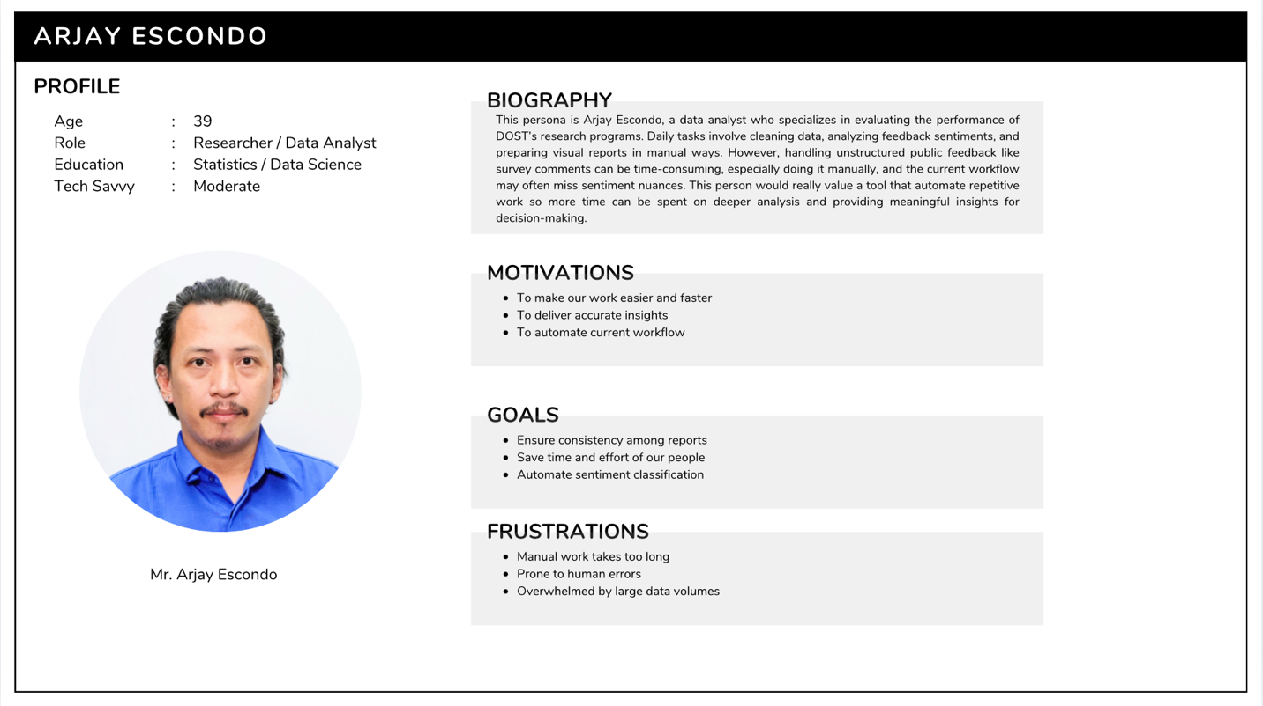
Customer: Chester Francisco
Biography: Chester Francisco is a Senior Research Specialist in Management Information Systems at DOST-STII who ensures digital platforms run smoothly and securely so staff can work efficiently without technical disruptions.
Motivations: 1. To automate current workflow, 2. To improve operational efficiency, 3. To support data-driven decision-making
Goals: 1. Ensure seamless integration of CitiSense into existing DOST systems, 2. Maintain system stability and security, 3. Provide reliable tech support for staff using the tool
Frustrations: 1. Inefficient manual processes, 2. Slow turnaround of data reports, 3. Frequent human errors in data handling
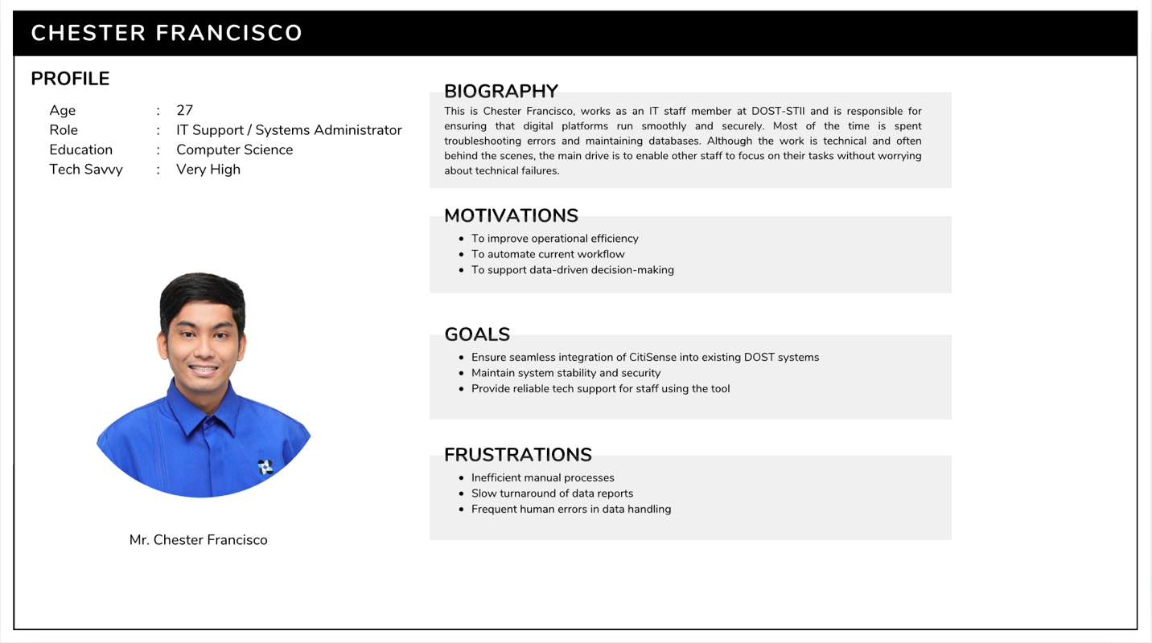

Empathy Map
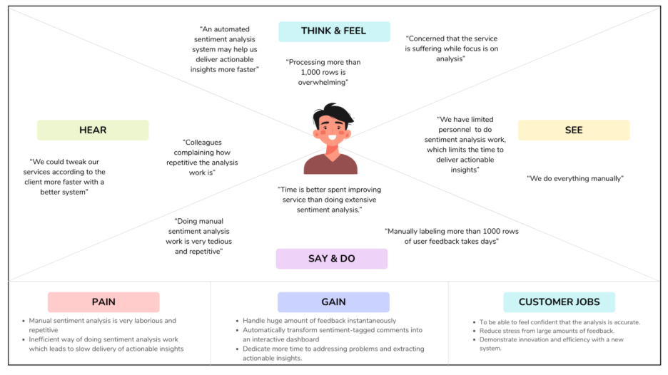

Stage 2: Define
Introduction
For the second stage of the design thinking process, our group utilized all the information gathered during the first stage, Empathize, where we conducted several interviews with our client and customers. Utilizing all the collected information, our group carefully analyzed the perspectives, insights, and challenges of each person involved in this project in order to determine a clear point of view (POV) and problem statement. Establishing a proper and organized structure was crucial for our group since it would serve as a guide in preparing for the other stages of the design thinking process.
The first stage of design thinking generated a huge amount of information with the use of interviews and user experiences, and with this, it is necessary for the team to organize and synthesize the findings. This will allow the team to categorize all the user experiences and challenges. With the help of this process, we transformed all the gathered information into structured and organized insights, ensuring clarity and harmony among the team members.

Clustering Problem Ideas
As you can see in this figure, our group lists challenges with the current manual sentiment analysis of the DOST-STII IRAD department and categorizes them into four main categories, namely: Inefficiency Problems, Technology Gaps, and Time Optimization. These categorizations were consolidated through a group discussion in order to highlight the root causes and issues that affect the efficiency, innovation, and productivity of the said department.

Inefficiency Problems
The current manual sentiment analysis of the DOST-STII IRAD department consumes a lot of time and effort to execute the process effectively. This inefficiency affects productivity and makes it difficult for data analysts to handle and analyze large amounts of data. In addition, there is a high chance of uncertainty for the accuracy of results, and this may lead to doubts about the reliability of the insights that came from the feedback. Moreover, these challenges limit the ability of the department to make haste for data improvements.

Technology Gaps
The third cluster of issues is about the absence of technology and system integration. Currently, the DOST-STII IRAD department has no automated system for its sentiment analysis, for them to upload and analyze feedback, which then results in a delayed or slower processing of sentiments with several inconsistencies. There is a lack of tools for properly managing and processing large amounts of data, which leads to difficulty in making scalable operations. Furthermore, the absence of an integrated visualization dashboard also prevents users from easily identifying and analyzing trends and interpreting results accurately and strategically.

Time optimization
The manual sentiment analysis process creates an excessive amount of workload for employees, specifically when it comes to handling large amounts of feedback from people who experience the services of DOST-STII. Tasks such as reading, categorizing, and interpreting customer feedback are some of the primary examples of repetitive work that DOST-STII employees face every day. These tasks take up valuable time that could be used for other priorities and innovations.
Problem Statements
- Doing manual sentiment analysis work is tedious and repetitive
- Data analysts could be doing a lot more tasks involving the betterment of the services rather than focusing much of their time on manual sentiment analysis.
- There is a need for an automated sentiment analysis system that can handle both English and Tagalog languages.

How Might We Questions
After identifying the problem statements, our group then proceeds to create “How Might We” questions. These questions will turn the identified issues into new opportunities for innovation, guiding our group to generate effective and innovative solutions. The problem statements serve as a stepping stone for developing these types of questions and to ensure that our group is aligned with the needs of our client and customers.
Here are the How Might We questions that our team initiated:
- How might we reimagine helping IRAD employees to transform raw feedback data into actionable insights that directly improve service delivery automatically?
- How might we reimagine helping IRAD employees in streamlining their current manual sentiment analysis workflow?
- How might we reimagine enabling IRAD employees to deliver greater value by focusing more on improving service delivery, instead of spending excessive time on manual sentiment analysis?

Conclusion
There is a need for improvement regarding the manual process of the sentiment analysis of the DOST-STII IRAD department. The clustered problems identified in the paper highlight the need to have an automated sentiment analysis system. In order for the team to be aligned and guided, we formulate clear problem statements. The “How Might We” questions serve as a guide to create possible innovative solutions that should address efficiency and accuracy of the process. In addition, implementing automation and visualization tools would reduce employee workload and improve the accuracy of insights. To sum it all up, the analysis emphasizes the importance of integrating and adopting technology-driven solutions in order to enhance productivity, innovation, and service quality within the department.

Stage 3: Ideate
Introduction
At this stage of the design thinking process, our group gathered together to identify each of our own ideas to integrate into the website application. This stage allows us to combine different ideas and make sure that the goals of this project are met.

Brainstorming Session
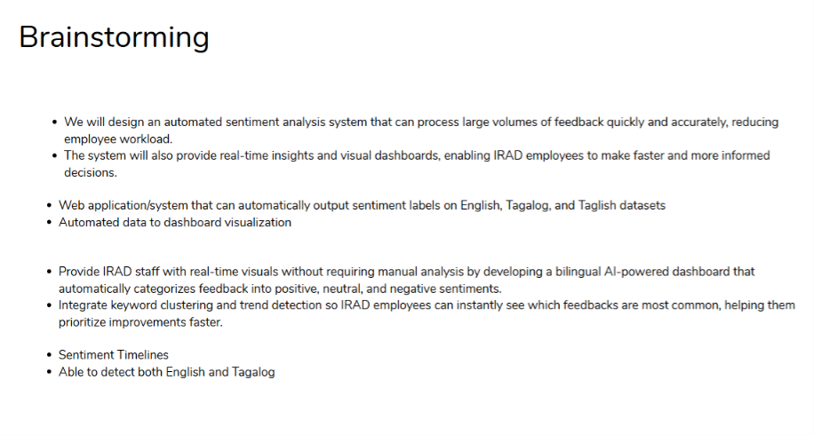
Our group gathered in an online meeting to discuss our opinions on addressing the client’s needs and solving challenges regarding their system.

Crazy 8
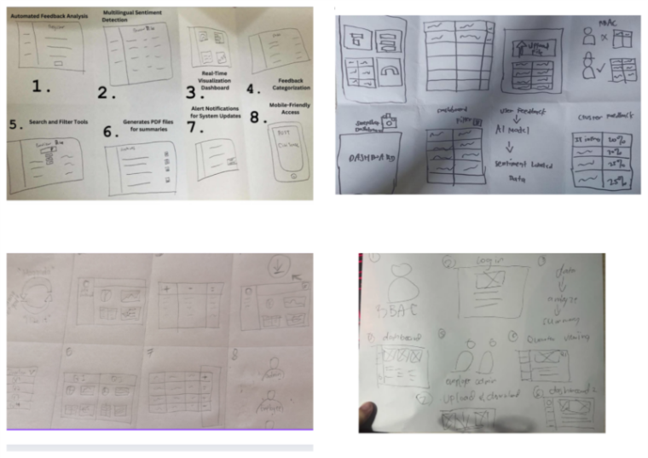
In this session, each member contributed their ideas for the making of the Crazy 8. We included features that we want to integrate in the website application and explained what each drawing represents.

Post-It Voting
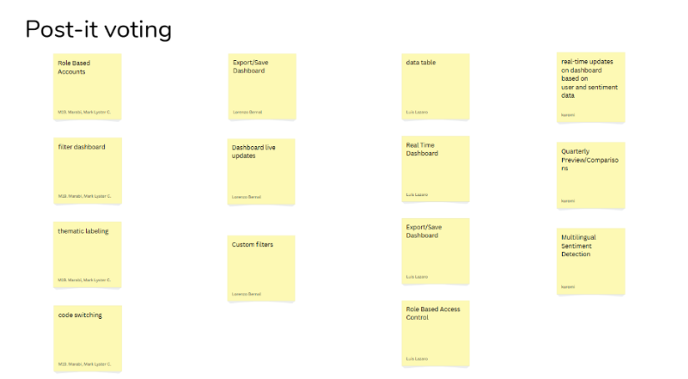
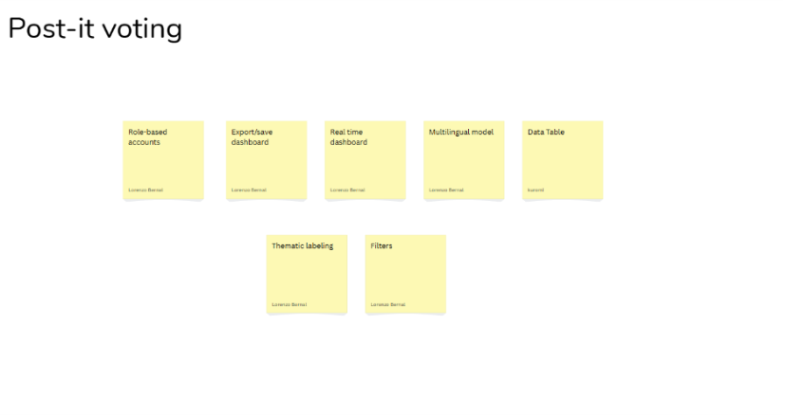
After discussing and finalizing the Crazy 8, our team, Quadthink proceeded with a post-it voting assessment. Each member had an opportunity to vote for the ideas that were most innovative and aligned with the project’s objectives
.
Feasibility-Viability-Desirability Analysis
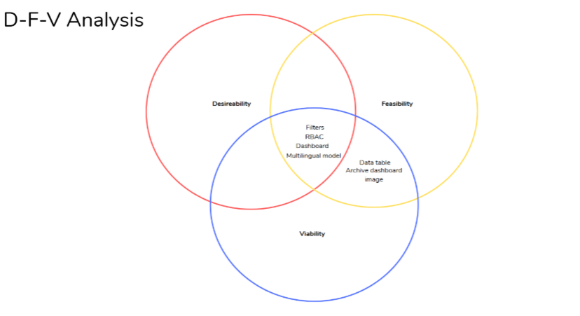
After the post-it voting, our group proceeded with the Feasibility-Viability-Desirability Analysis to further evaluate the selected ideas. By utilizing this framework, our group was able to narrow down our options and prioritize ideas that demonstrated the strongest qualities for the website application.
For the functionality that encapsulates the three categories of the Venn diagram, we have:
- Filters
- Role-Based Access Control
- Dashboard
- Multilingual AI Model
These are the functionalities that our customers desire most, are feasible with current technologies, and are viable as they provide long-term value for our clients in the context of service delivery.
As for Feasible and Viable only, we have:
- Data Table
- Generate Reports
These are only at the feasible and viable level, as these functionalities can be done outside our system, such as editing the data in Google Sheets. As for Generate Reports, our clients can make inferences and generate reports according to what they are currently seeing in the dashboard and data table outside of our proposed system.
Stage 4: Prototype
Introduction
At this stage of the Design Thinking process, our group, QuadThink, focused on creating prototypes that demonstrate the core features of our system solution. Each prototype highlights how users will interact with the system to ensure usability and efficiency. Our group conducted several meetings with our clients to demonstrate and simulate real user experiences. Furthermore, through this scenario, we were able to visualize how our system could operate in practice. Overall, these prototypes will serve as a foundation for future development, providing our group with a clear direction for enhancing the system's functionality.

Storyboard of the current manual workflow of our client (to visualize what our system aims to solve, which is the automation of the manual sentiment analysis workflow):
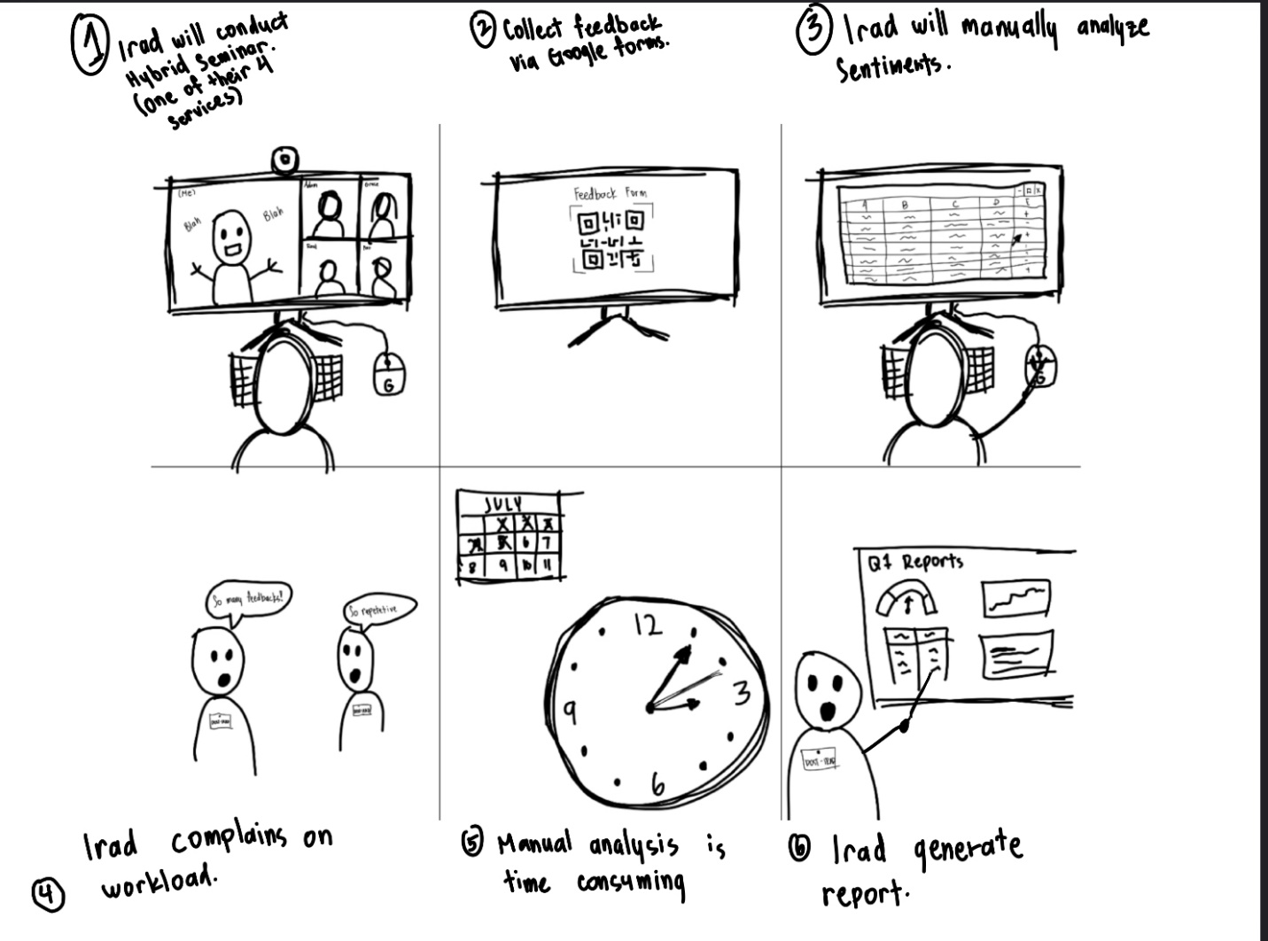

Storyboard for our proposed system, along with the benefits of using it:
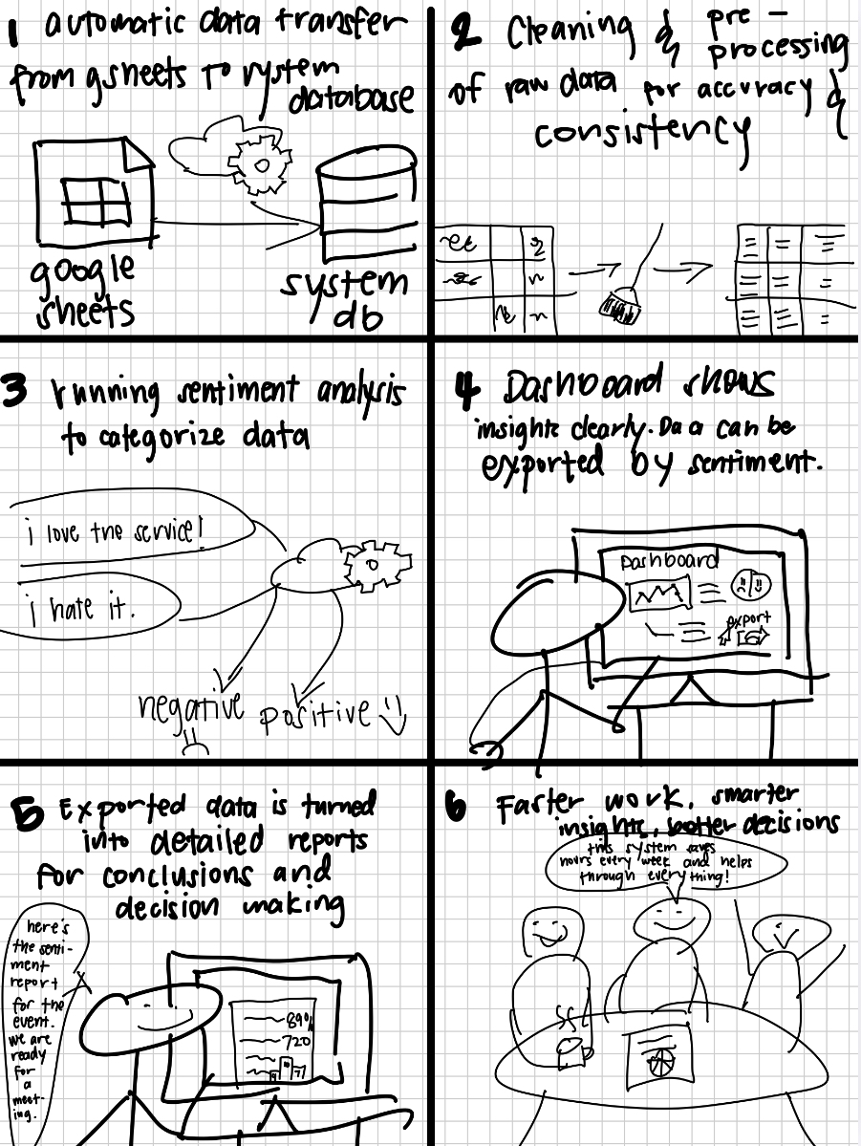

Prototype
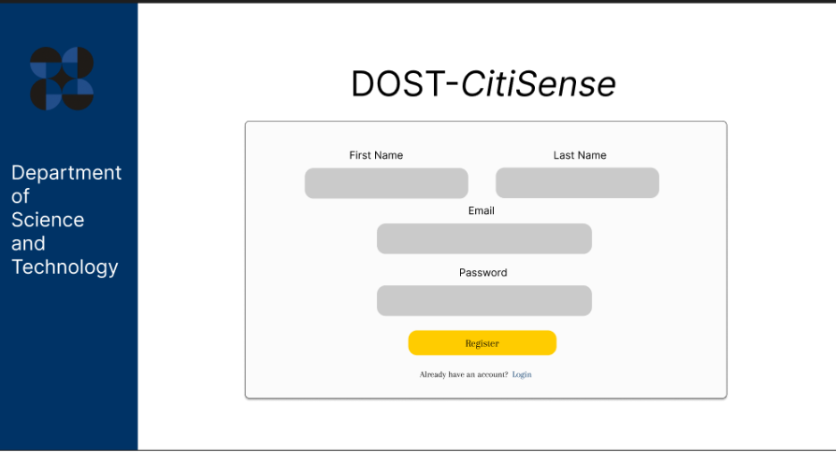
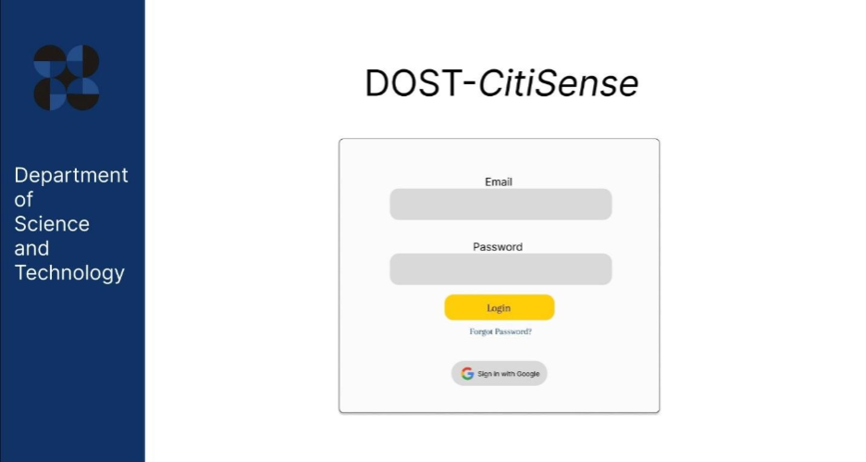
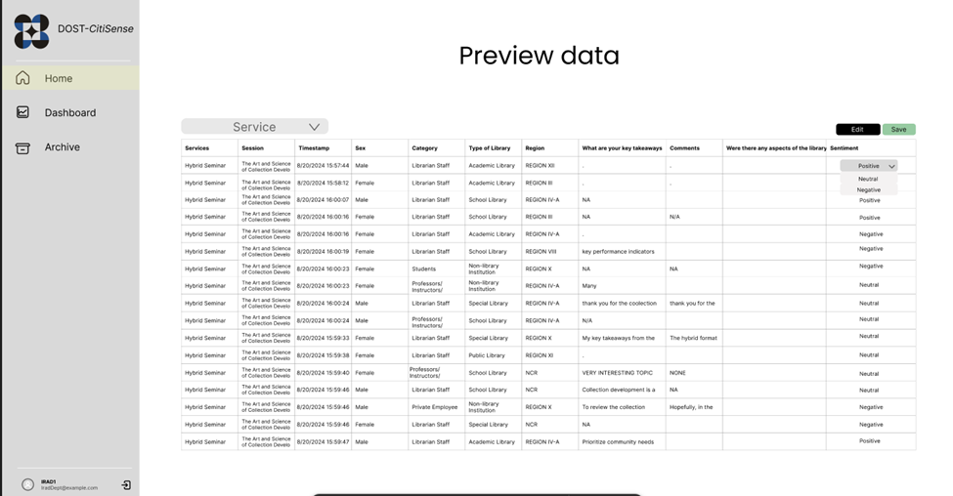
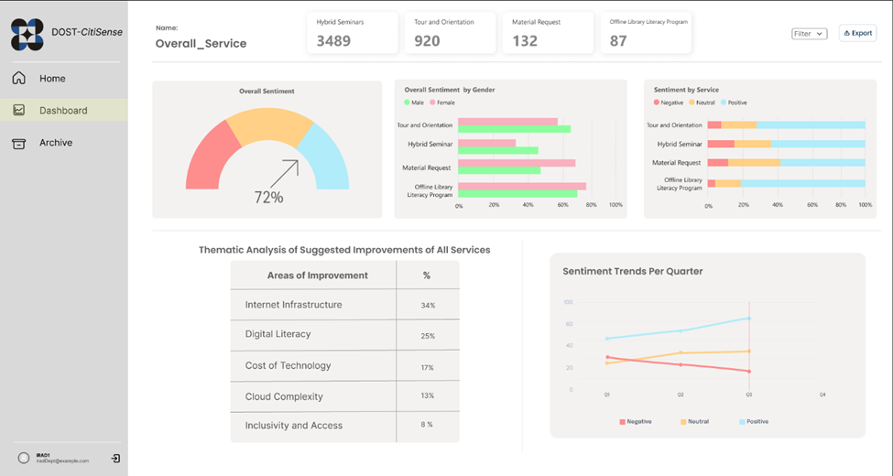

Stage 5: Testing
Introduction
For the fifth stage of the Design Thinking process, our group, QuadThink, presented the prototype of our automated sentiment analysis system to our client for testing as well as feedback. Our group demonstrated how to use the system, which includes properly addressing the challenges of the manual sentiment analysis system, such as providing a visualization dashboard for feedback analysis. The prototype is carefully designed to align with the goals and objectives of our client and was guided by references from tools to cater to the needs of the client. Aside from the minor adjustments to the system, the client appreciated the overall functionality of the system and is positive that this project would be beneficial for the decision-making process of the DOST-STII IRAD department.
Meeting Link: video1342409374.mp4
Client Comment:
- The client noted that they will add a column in the Google Sheets source data to reflect quarterly information. Once this column has been included, our group, QuadThink, will receive the updated data, enabling the system to incorporate a new filter in the dashboard for quarterly analysis alongside the existing per-service filter (e.g., January, February, March – Quarter 1). A total of 4 Quarters for the filter.
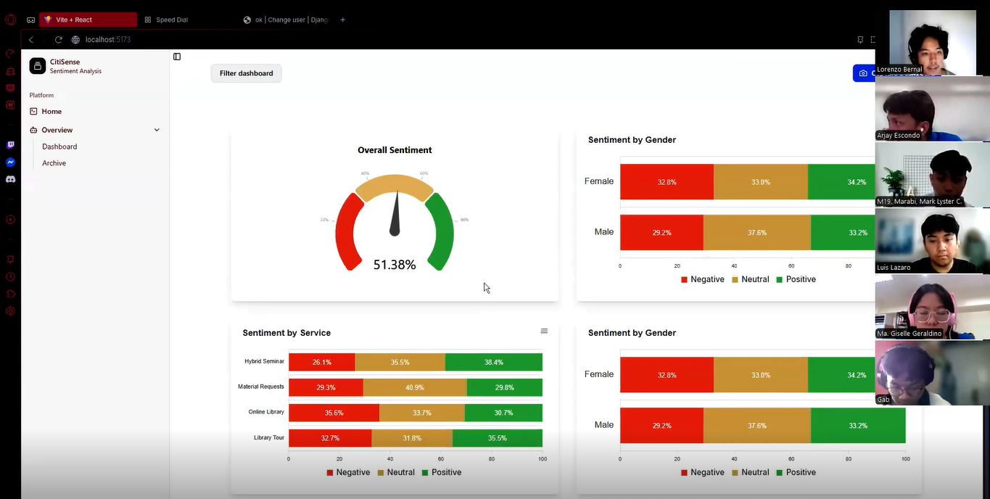

Data Flow Diagram
Level 0 – Context Diagram
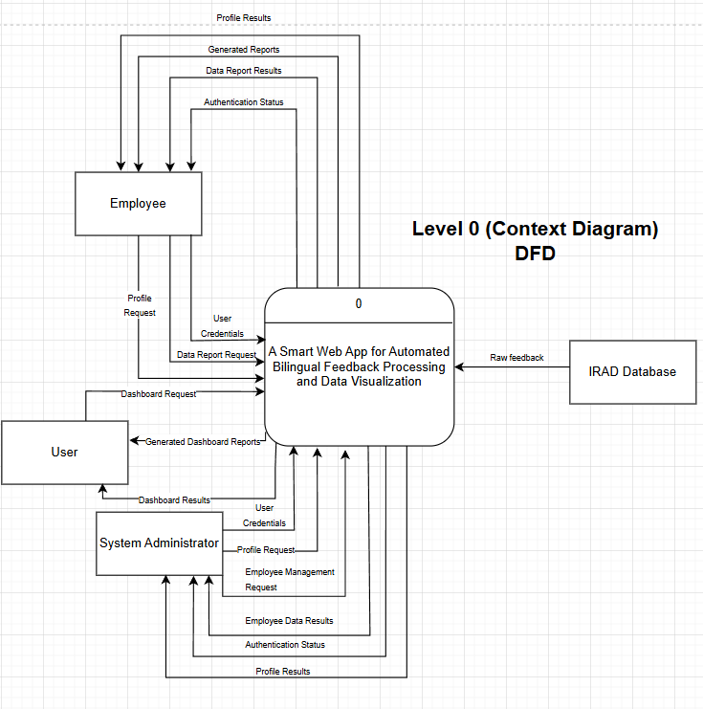

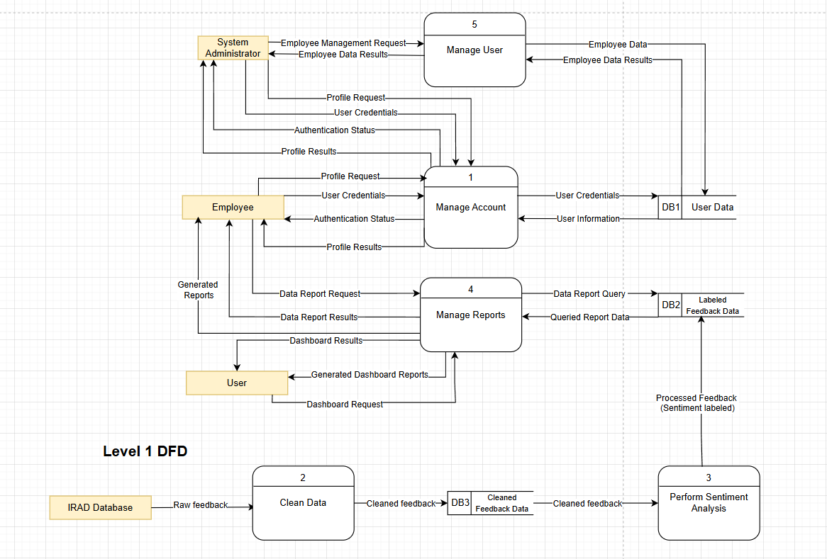
Level 1 DFD

Level 2 – 1.0 Manage Account
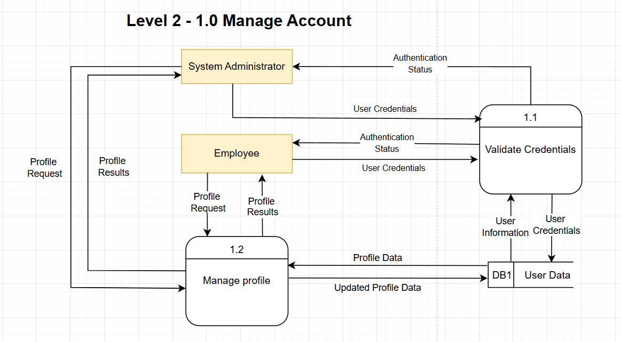

Level 2 – 2.0 Clean Data
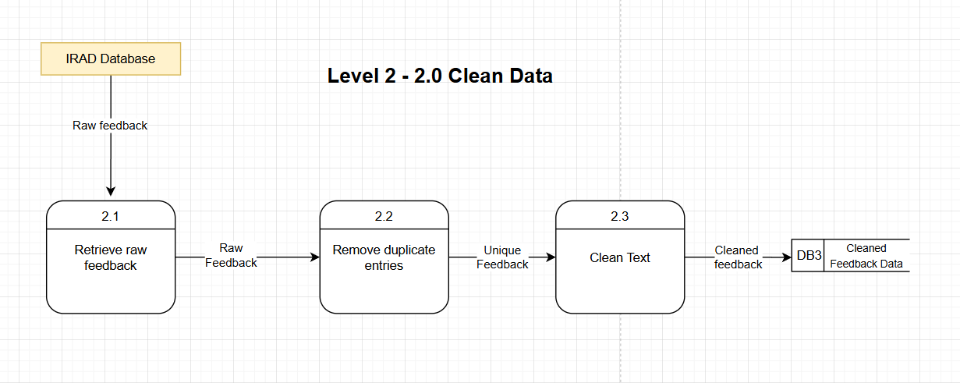

Level 2 – 3.0 Perform Sentiment Analysis
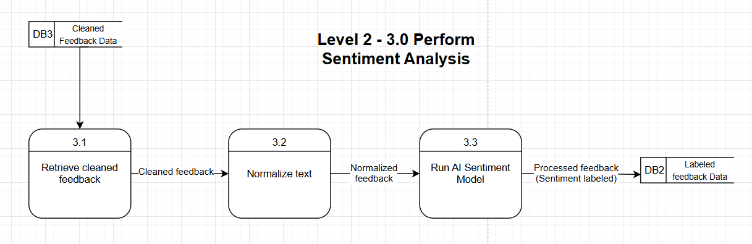

Level 2 – 4.0 Manage Reports
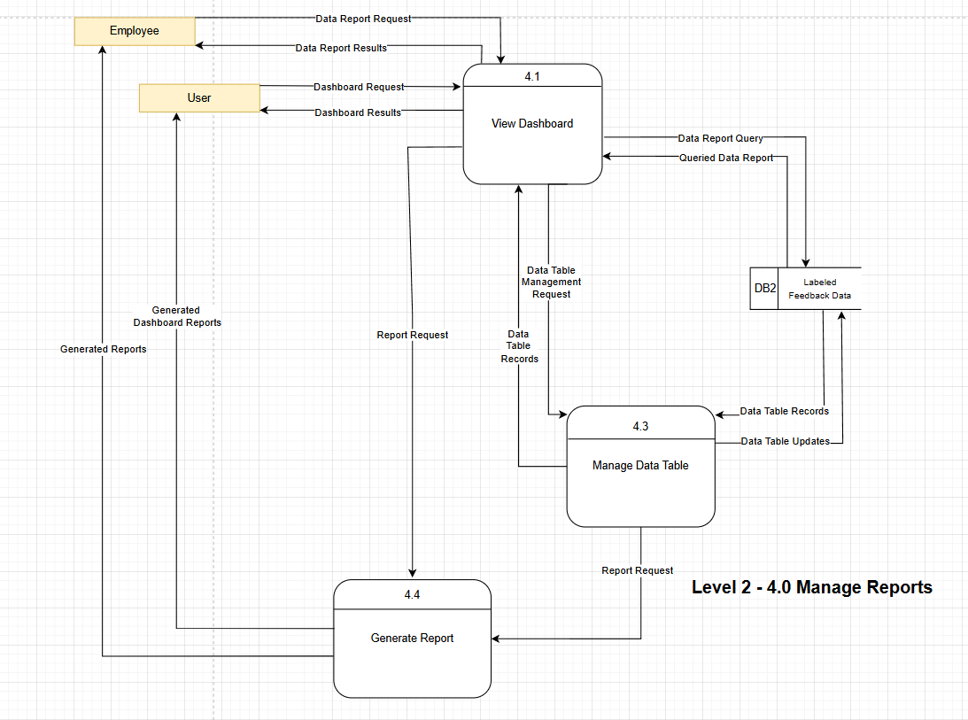
Level 2 – 5.0 Manage User
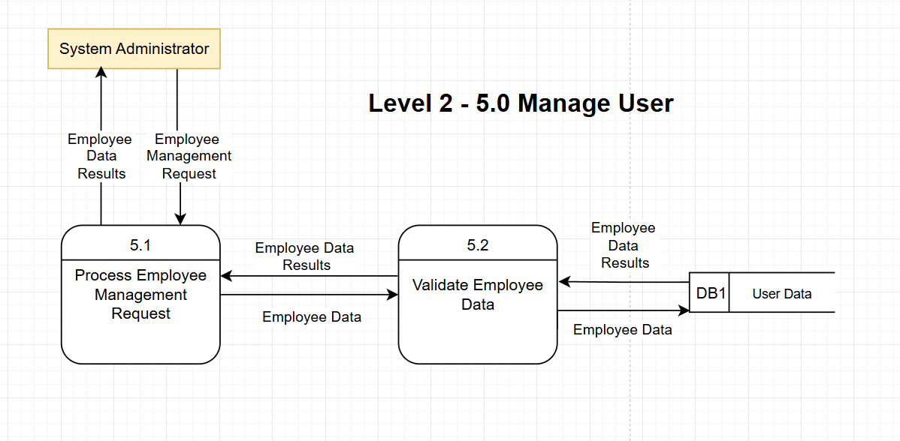

Use Case Diagram
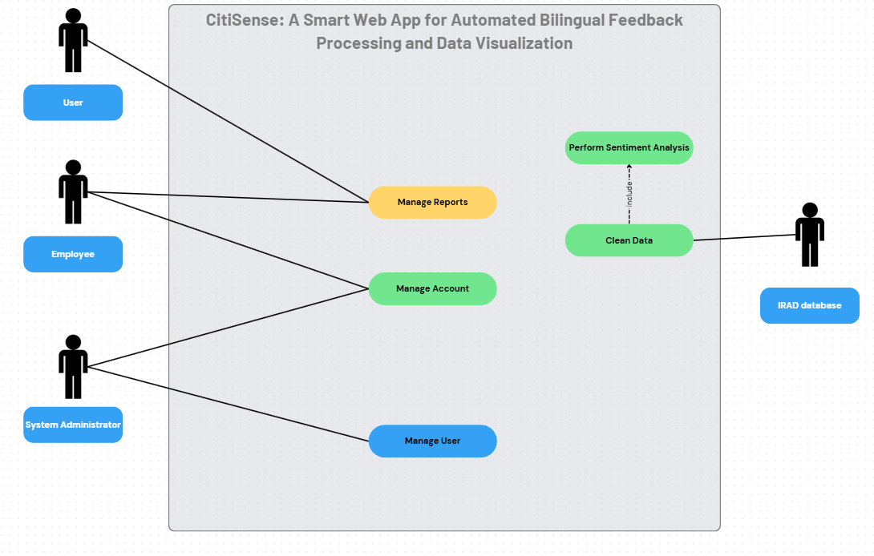

Use Case Fully Dressed
Fully Dressed Use Case - QuadThink.docx

Activity Diagrams
Activity Diagram for UC-01 (Register)
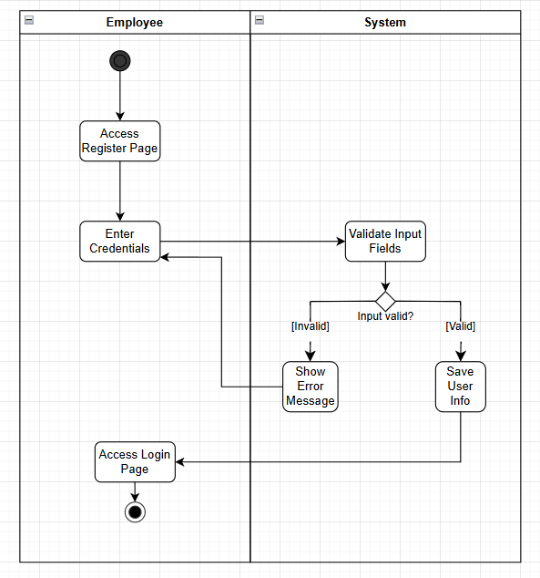

Activity Diagram for UC-02 (Login)
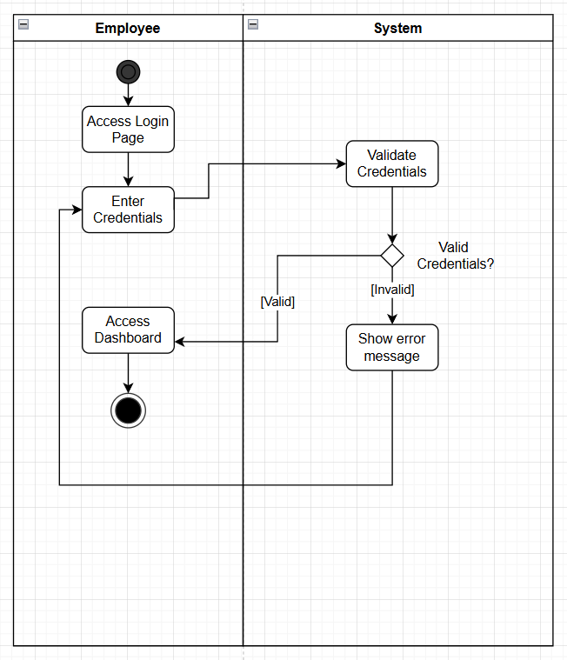

Activity Diagram for UC-03 (Edit User Profile - Employee)
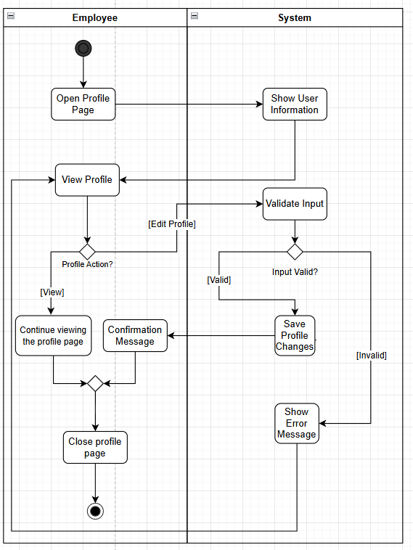

Activity Diagram for UC-04 (View Dashboard - User)
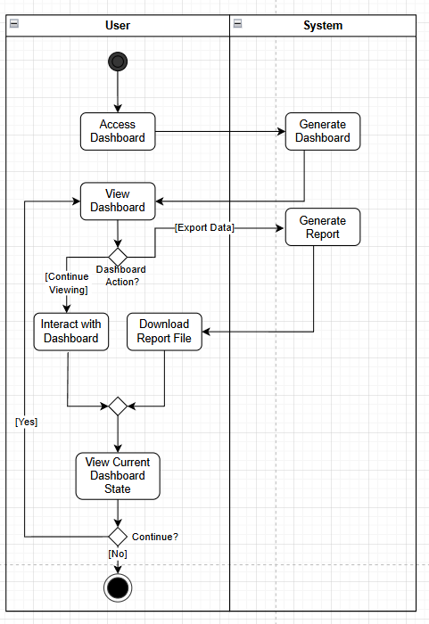

Activity Diagram for UC-05 (Manage Data Table)
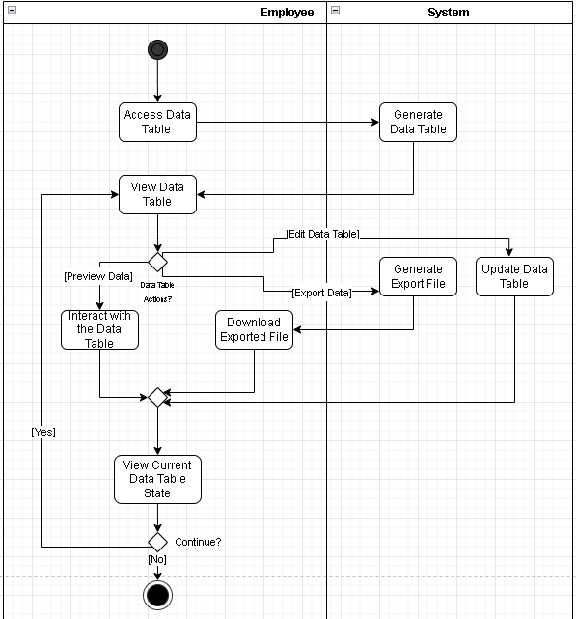

Activity Diagram for UC-06 (Perform Sentiment Analysis)
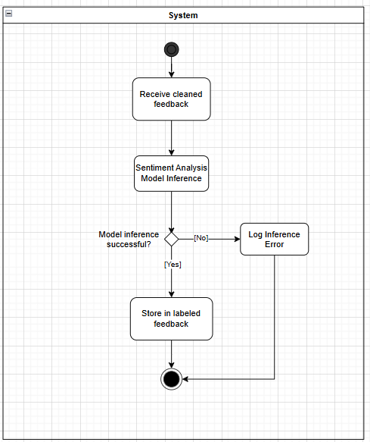

Activity Diagram for UC-07 (Administrator Panel Login)
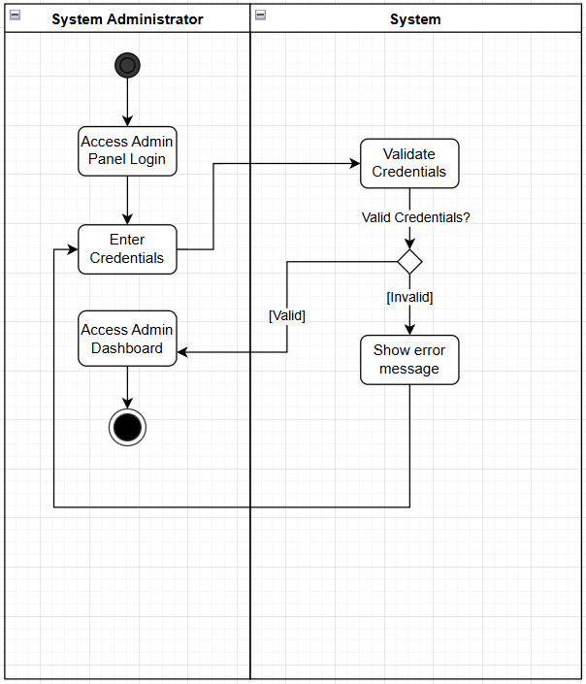

Activity Diagram for UC-08 (Assign Roles)
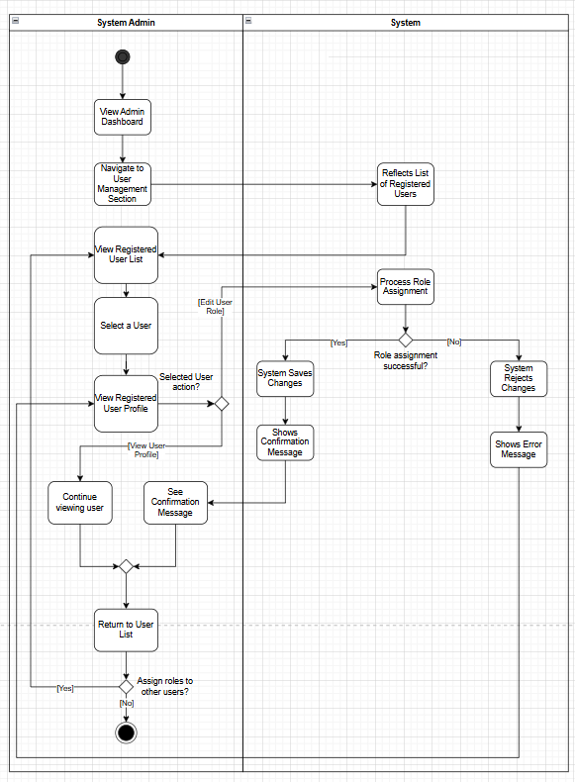

Activity Diagram for UC-09 (Manage User Details)
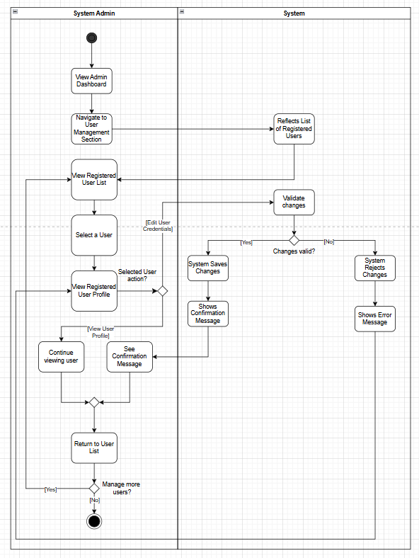

Activity Diagram for UC-13 (Clean Data)
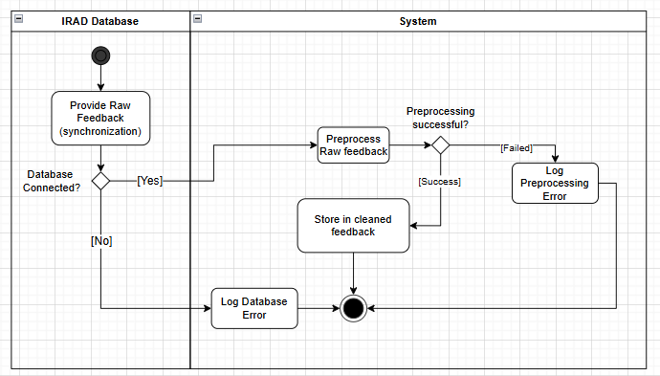

Activity Diagram for UC-14 (View Dashboard – Employee)
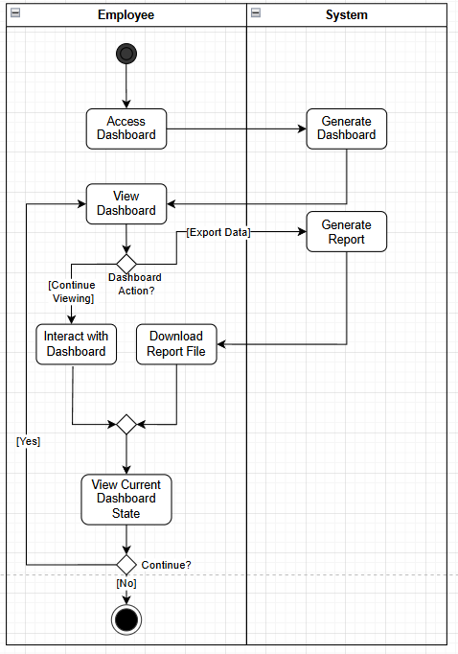

Activity Diagram for UC-15 (Edit User Profile – System Administrator)
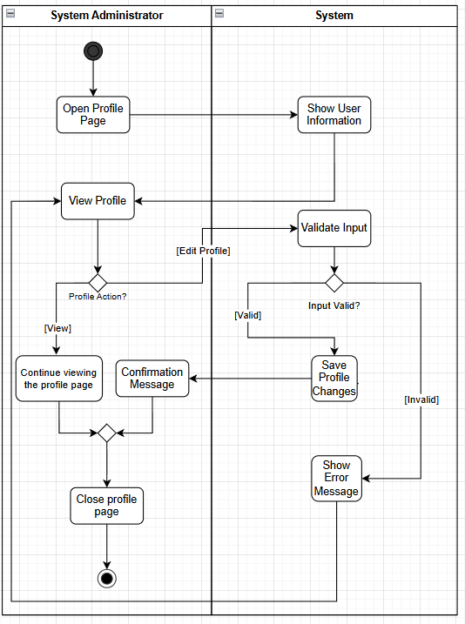

Updated Test Cases

- QuadThink_TestCaseTables.xlsx

Entity Relationship Diagram
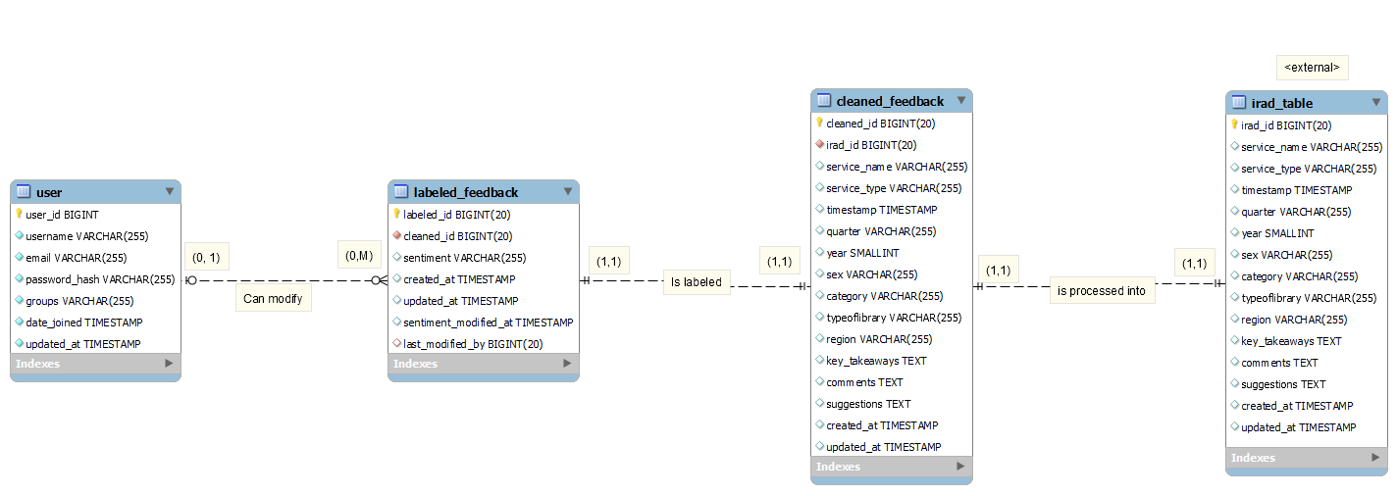

Technology Stack
- Frontend Framework
- React: Connects with the backend via APIs to display sentiment results.
- Backend Framework
- Django: Handles data processing, sentiment model integration, and API services
- Realtime Cloud database
- MySQL: Stores and manages all user, feedback, and sentiment data.
- Frontend/ Backend communication
- RESTful API: Enables real-time communication between React and Django.

Cloud Hosted Prototype
Prototype Link: https://fork-dost-citi-sense.vercel.app/
- Credentials:
  - Username: user@example.com
  - Password: password123
Vercel Dashboard
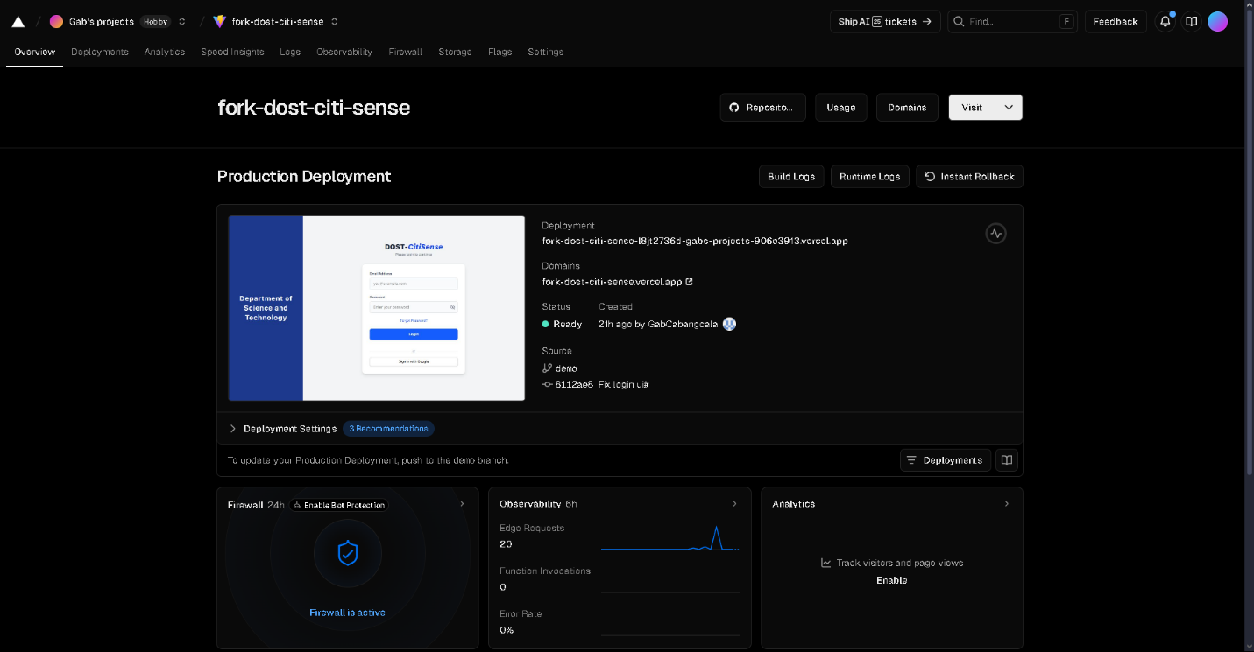

Links
Github APC-SoCIT project repository URL Link (demo branch): https://github.com/APC-SoCIT/APC_2025_2026_T1_MI232_G07-DOST-CitiSense/tree/demo
Openproject Team Site URL Link: Overview | APC_2025_2026_T1_MI232_G07 QuadThink CitiSense DOST: Sentiment Analysis System | OpenProject

Sprint 1 Ceremonies
Sprint Planning |Meeting Link|
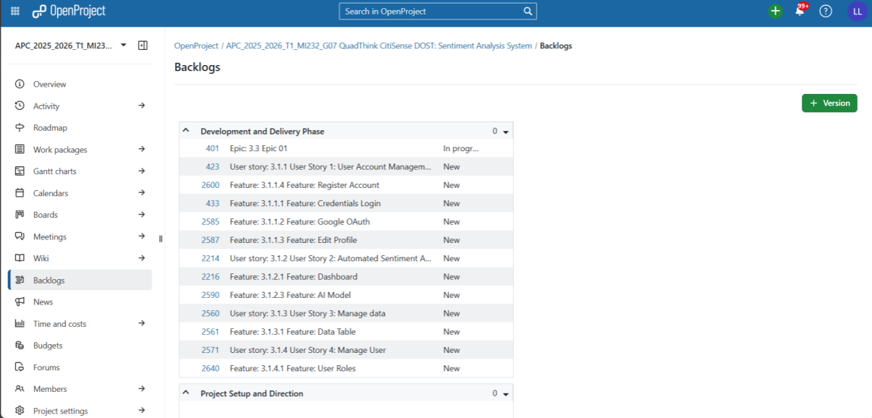
- Product Backlog

- Sprint Board
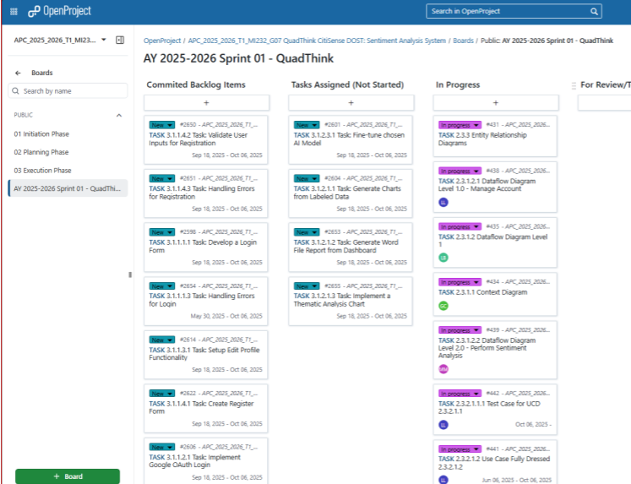
Backlog Refinement |Meeting Link|
- Product Backlog
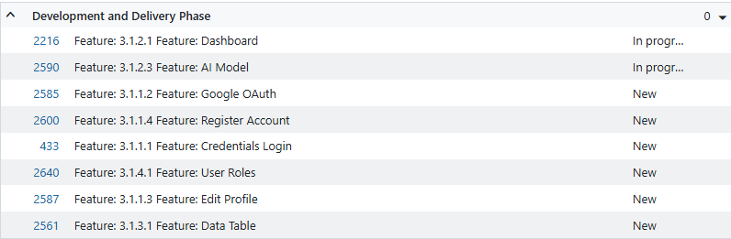

Sprint Review |Meeting Link|
- Product Demo

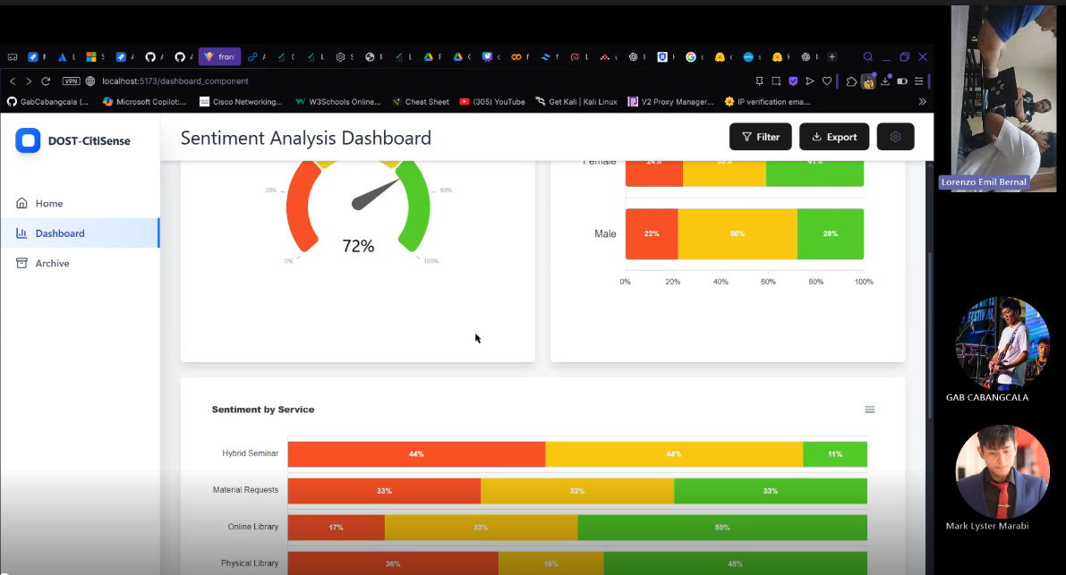

- Sprint Board

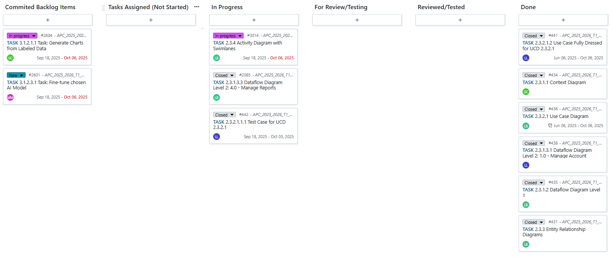
Sprint retrospective |Meeting Link|
- Glad, Sad, Mad Items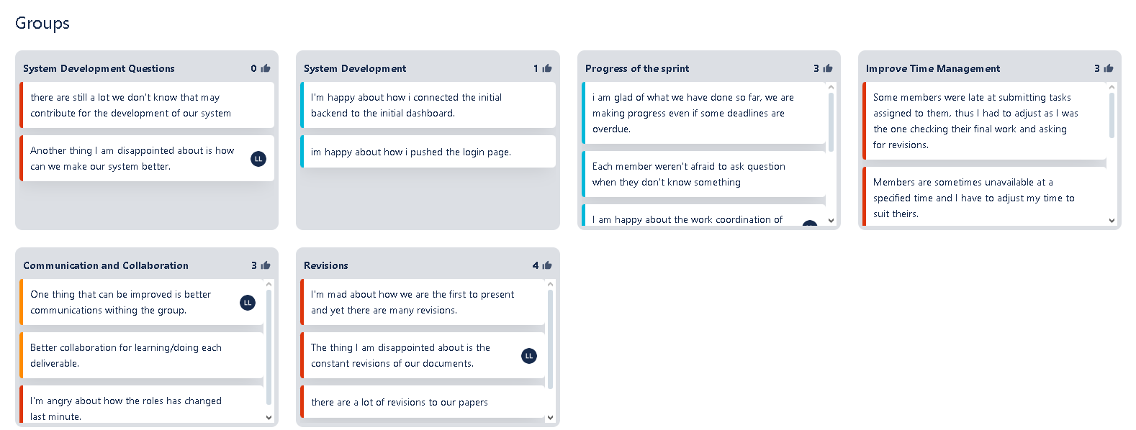

- Action Items
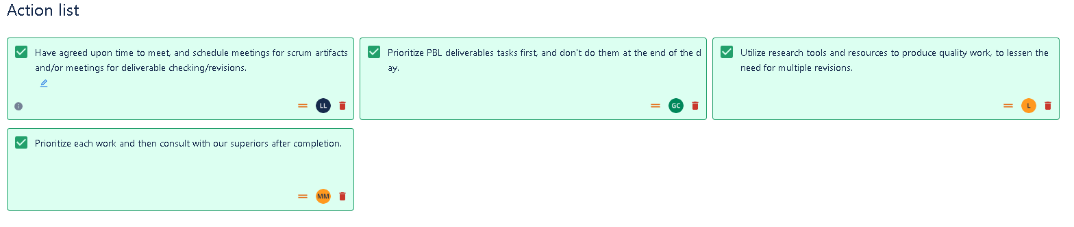

- OpenProject Work Packages
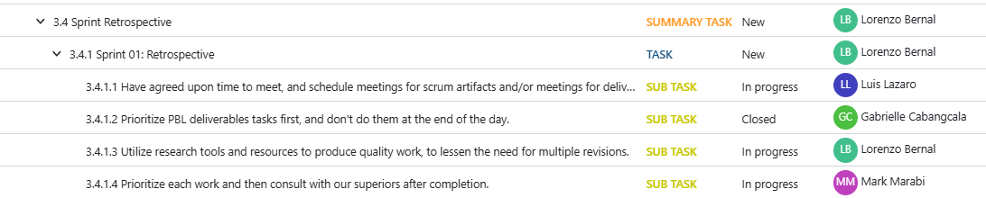

OpenProject Daily Scrum Outputs

OpenProject Daily Scrum Reports for Sprint 1 Week 1
Daily Scrum Report Day 01
- OpenProject: Sprint 1 Week 1 Day 01 Daily Scrum Meeting Individual Updated Report
- Scrum Report Video recording link from Group channel: |Link|
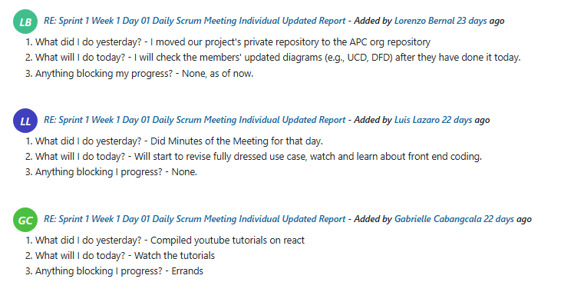

Daily Scrum Report Day 02
- OpenProject: Sprint 1 Week 1 Day 02 Daily Scrum Meeting Individual Updated Report
- Scrum Report Video recording link from Group channel: |Link|
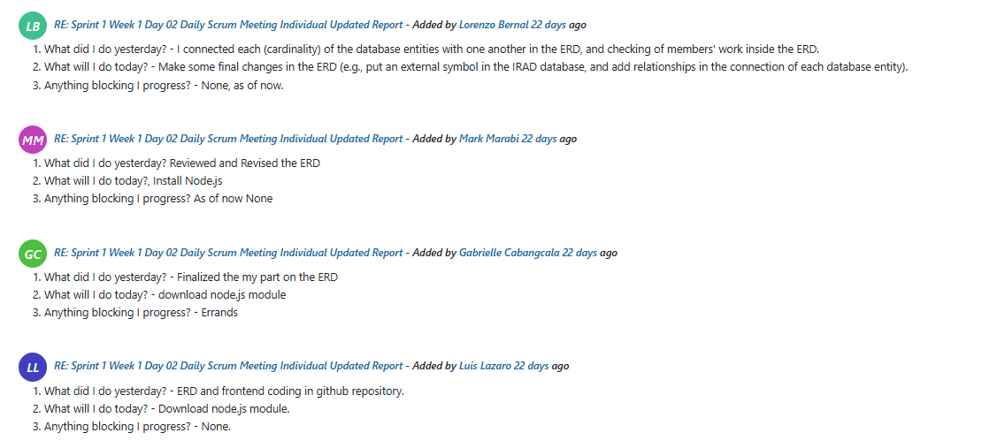

OpenProject Daily Scrum Reports for Sprint 1 Week 2
Daily Scrum Report Day 01
- OpenProject: Sprint 1 Week 2 Day 01 Daily Scrum Meeting Individual Updated Report
- Scrum Report Video recording link from Group channel: |Link|
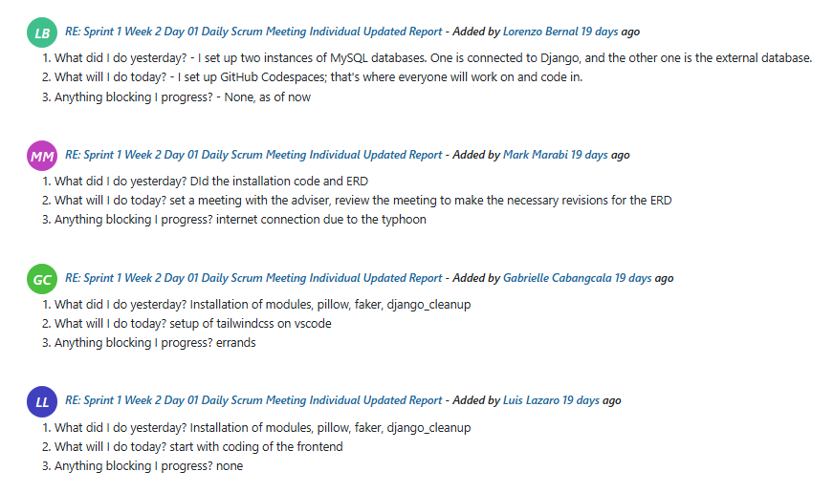

Daily Scrum Report Day 02
- OpenProject: Sprint 1 Week 2 Day 02 Daily Scrum Meeting Individual Updated Report
- Scrum Report Video recording link from Group channel: |Link|
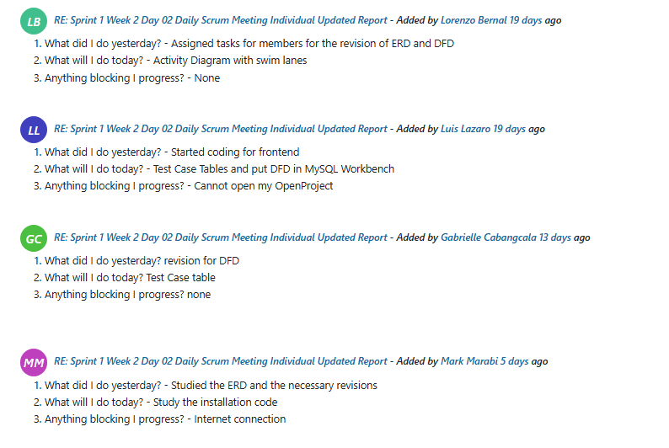
Daily Scrum Report Day 03
- OpenProject: Sprint 1 Week 2 Day 03 Daily Scrum Meeting Individual Updated Report
- Scrum Report Video recording link from Group channel: |Link|
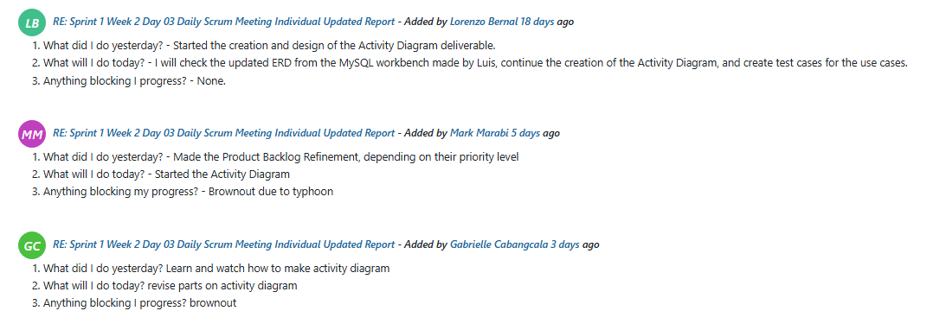

OpenProject Work Packages and GitHub Commits
Groupwork
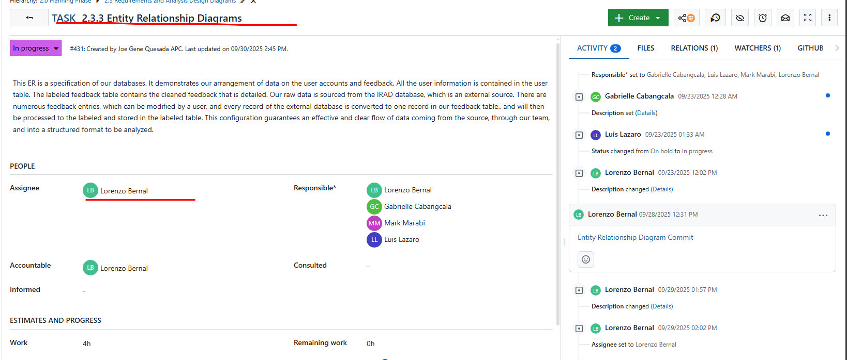
Entity Relationship Diagram |Link|

Corresponding Github repository commit |Link|
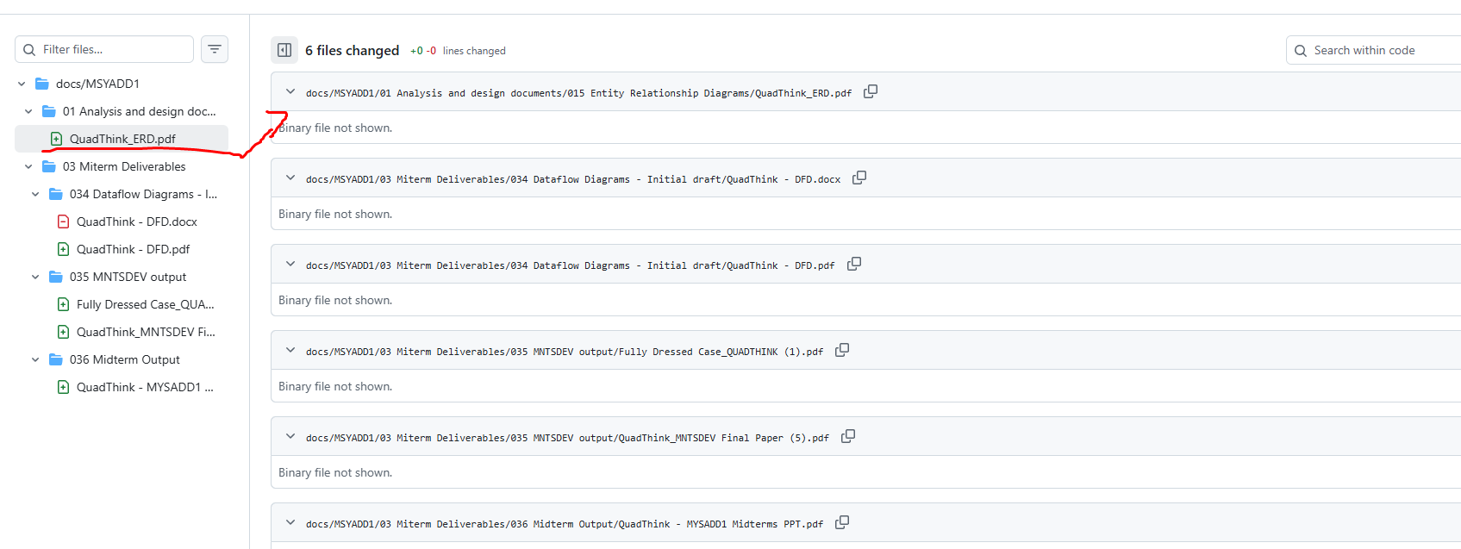

Activity Diagram with Swimlanes |Link|
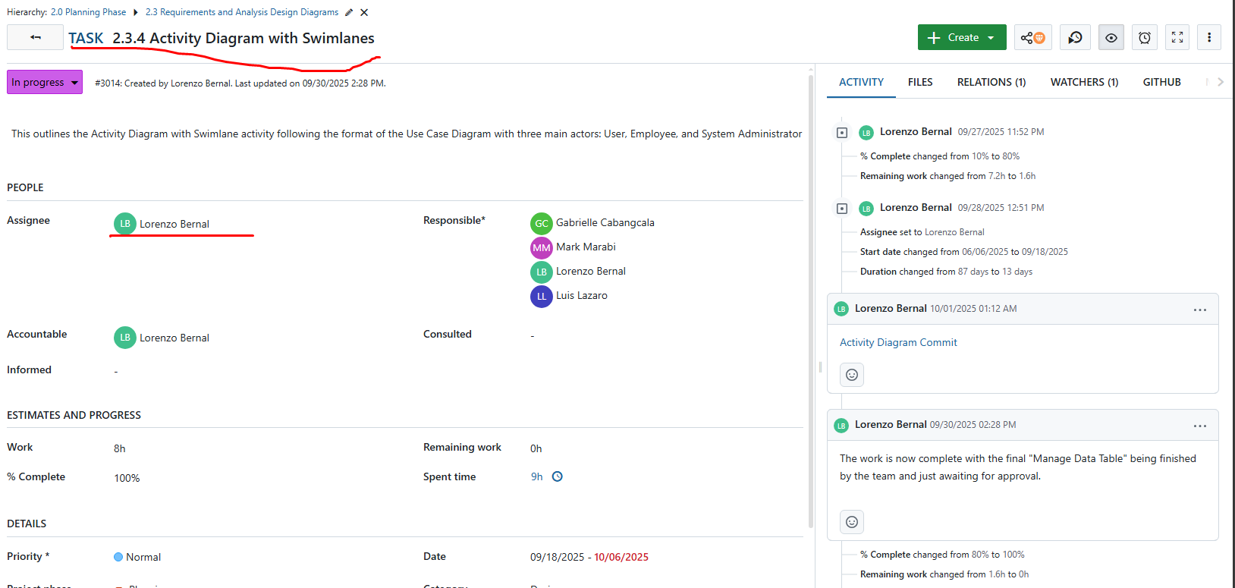

Corresponding GitHub repository commit |Link|
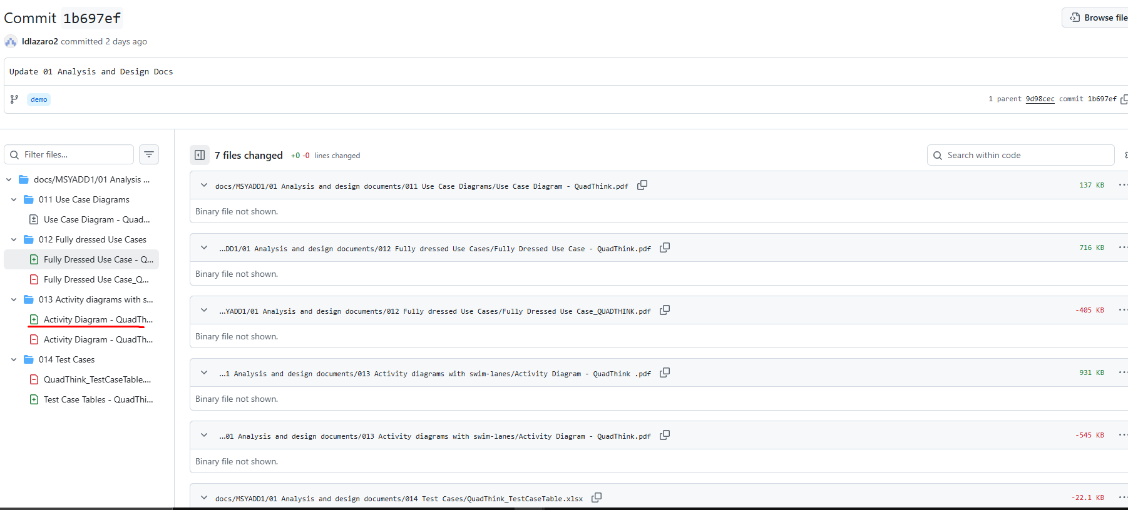

Test Case Tables |Link|
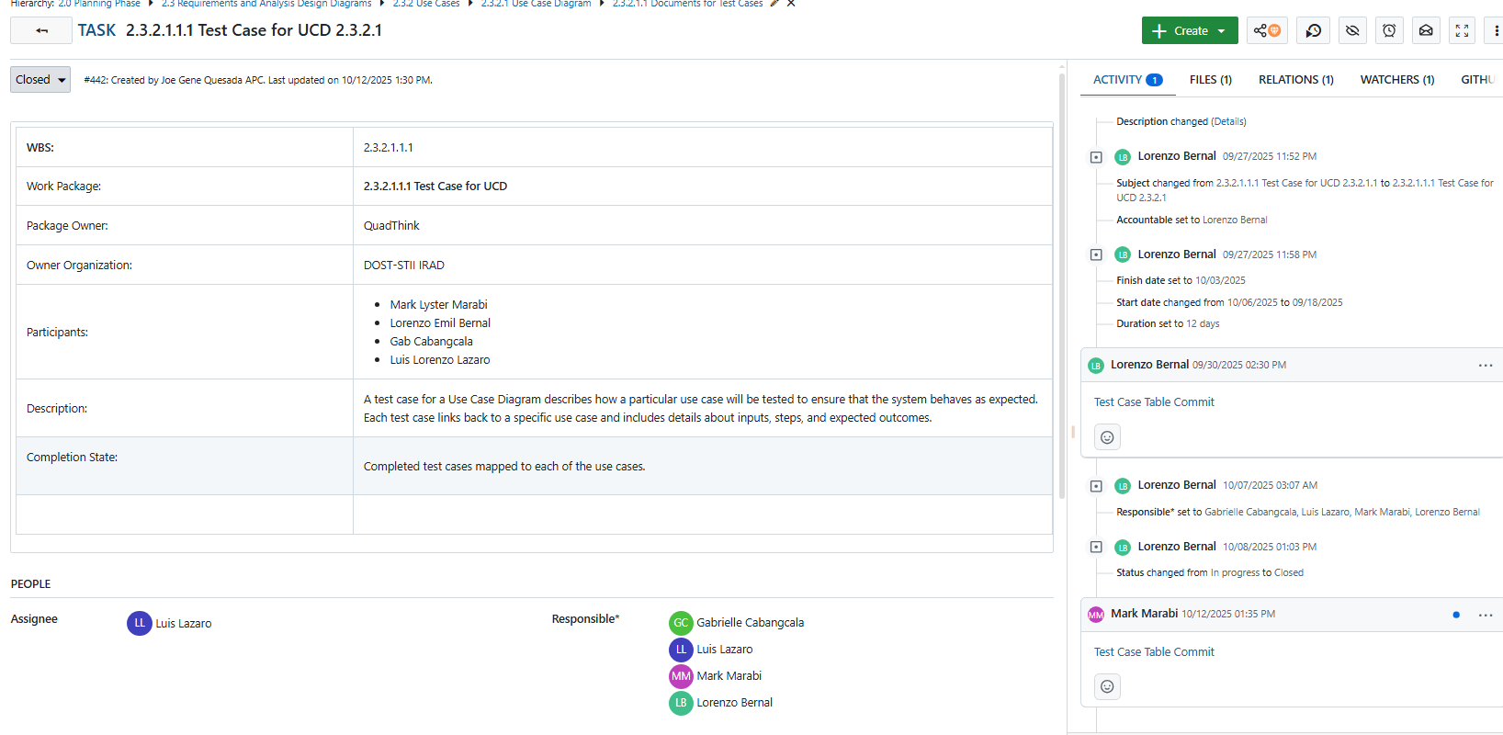

Corresponding Github repository commit |Link|
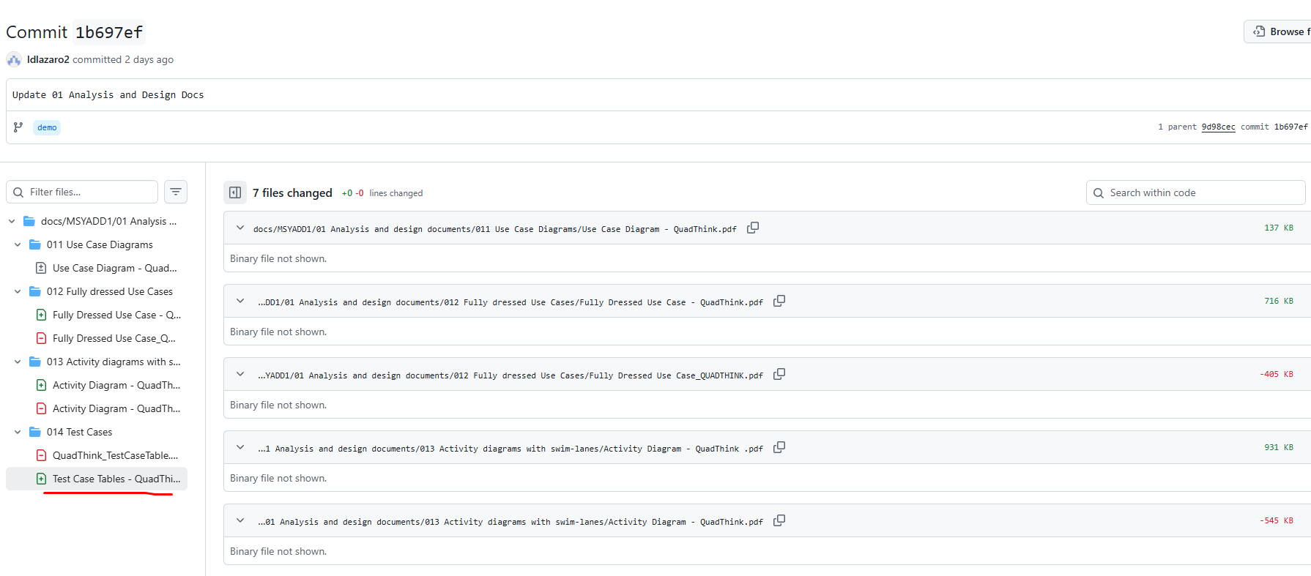

Fully Dressed Use Case |Link|
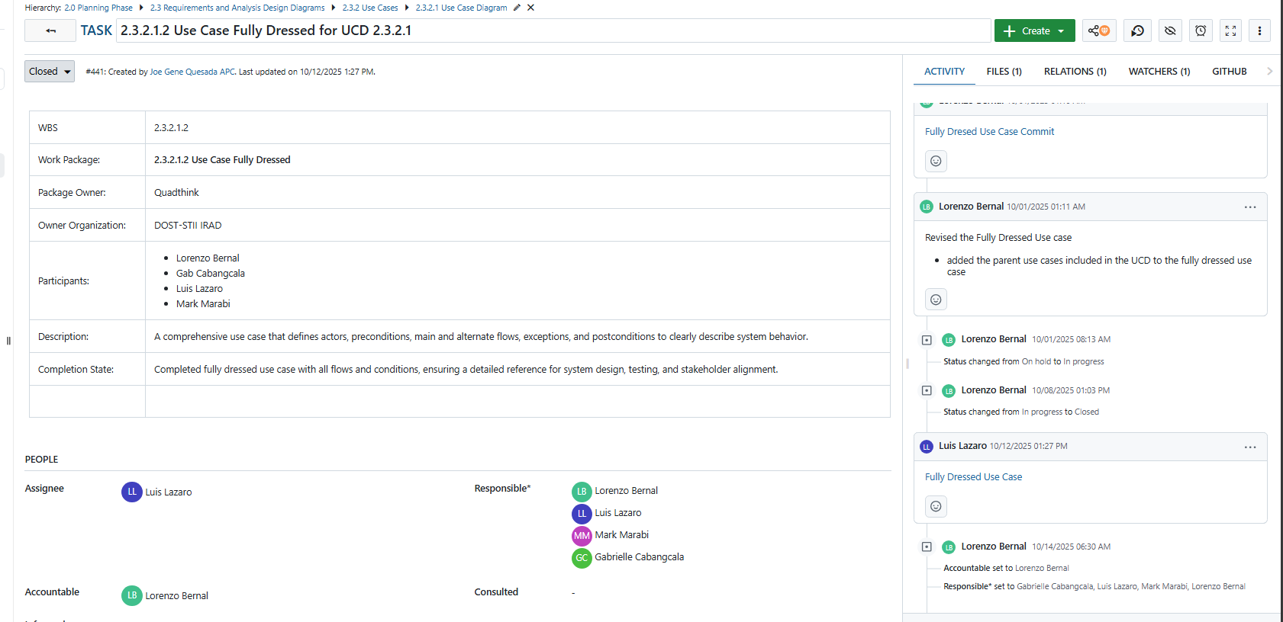

Corresponding Github repository commit |Link|
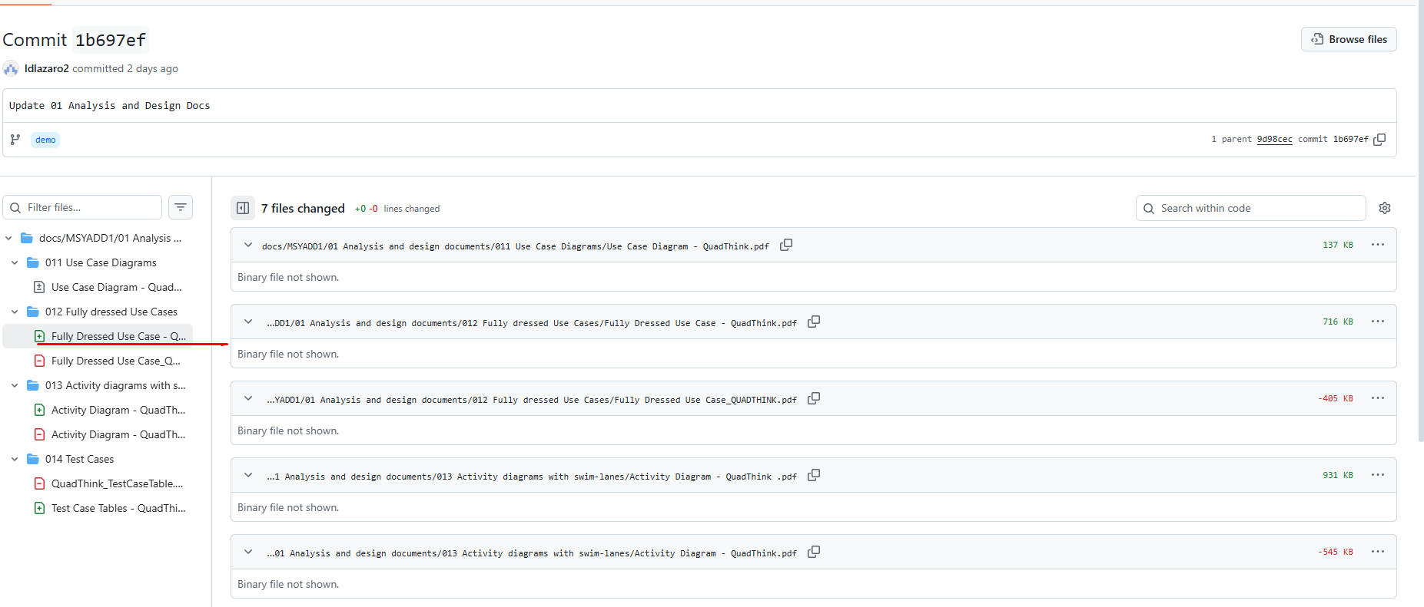

Solo work:
- Lorenzo Emil S. Bernal
Use Case Diagram |Link|


Corresponding Github repository commit |Link|
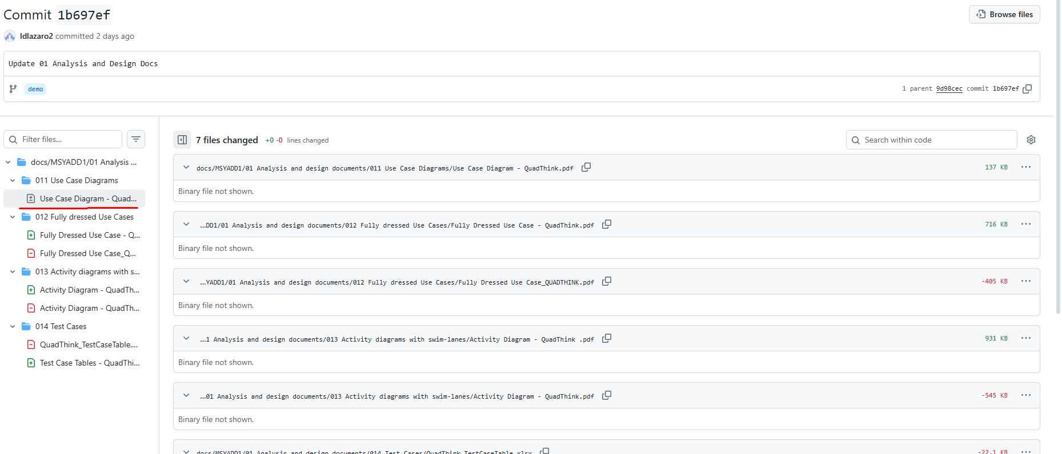

Stakeholder Analysis |Link|
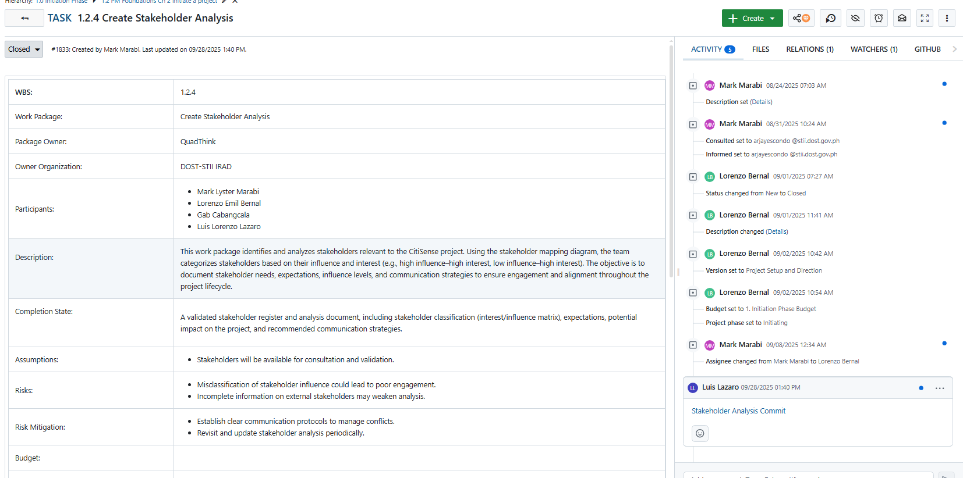

Corresponding Github repository commit |Link|
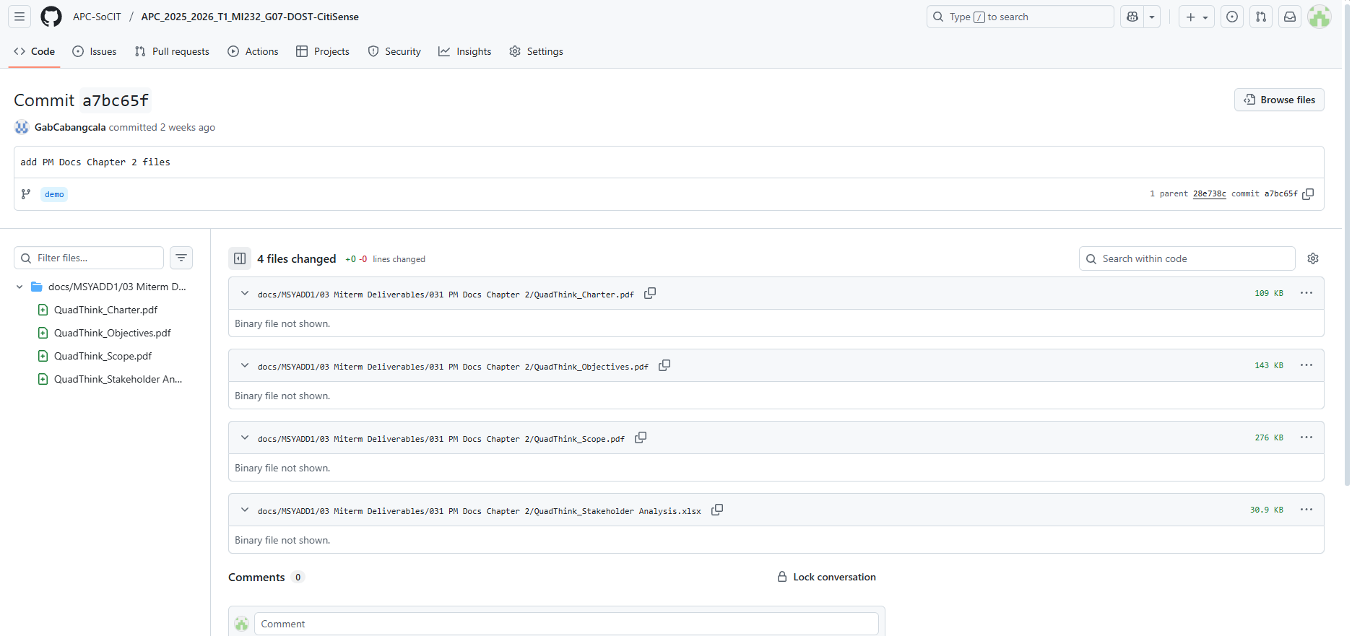

Dataflow Diagram Level 2 – 4.0 Manage Reports |Link|
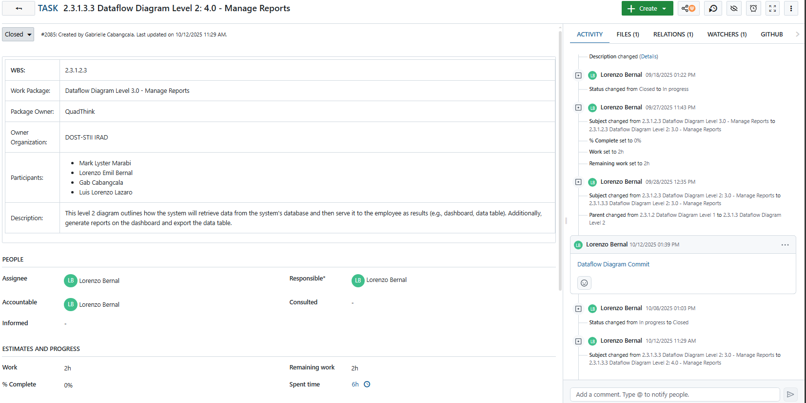

Corresponding Github repository commit |Link|
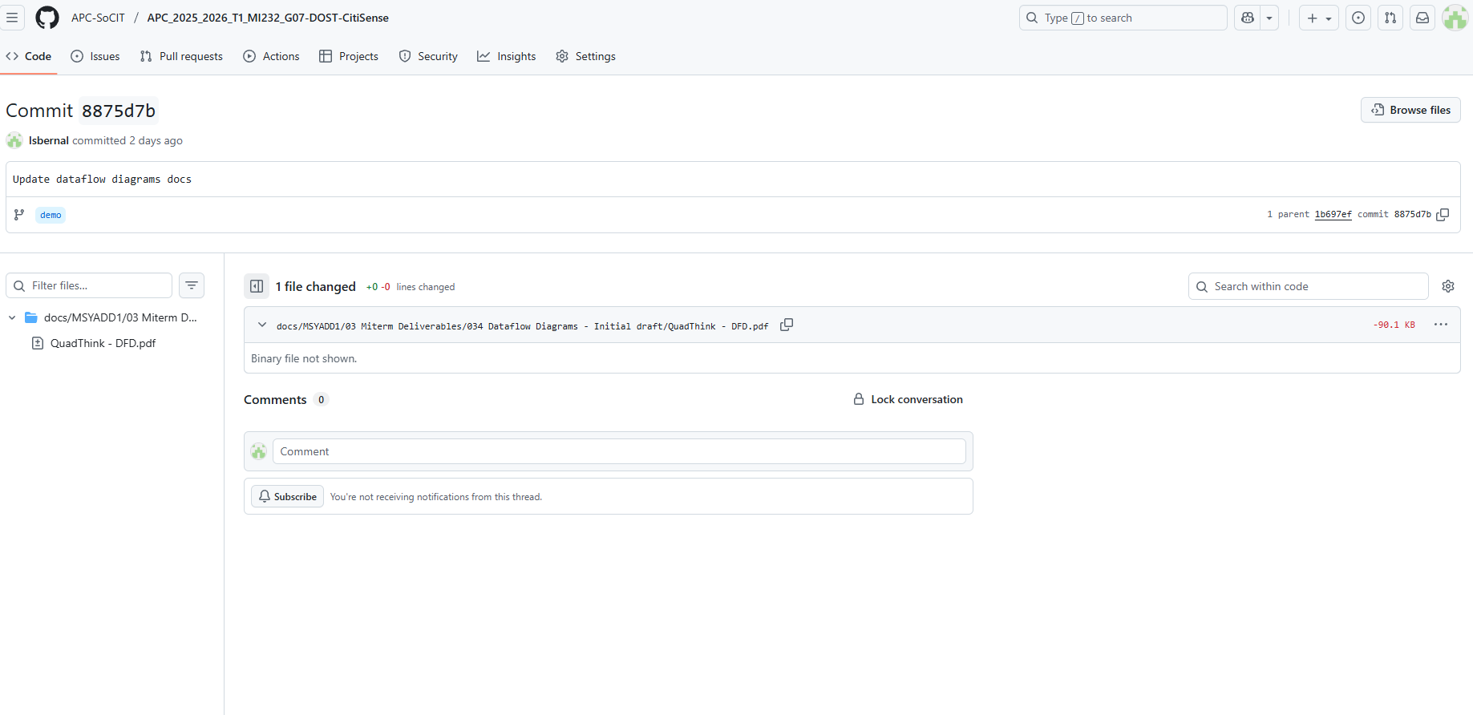

- Gabrielle Cabangcala
PM Docs |Link|
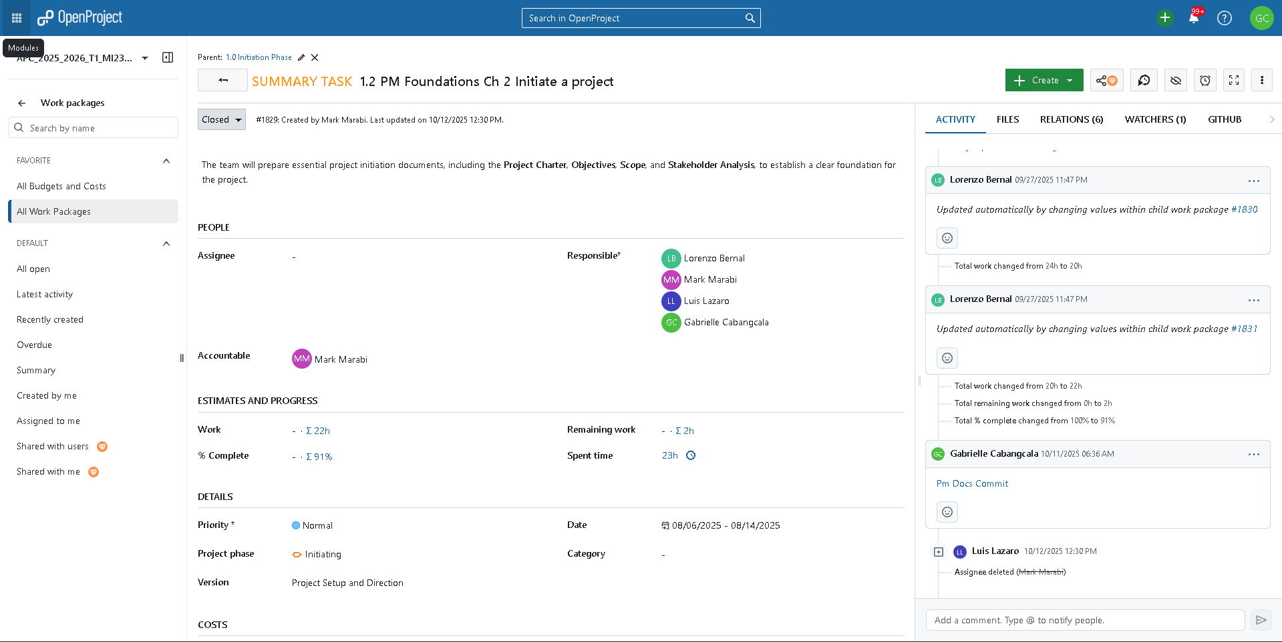

Corresponding Github repository commit |Link|
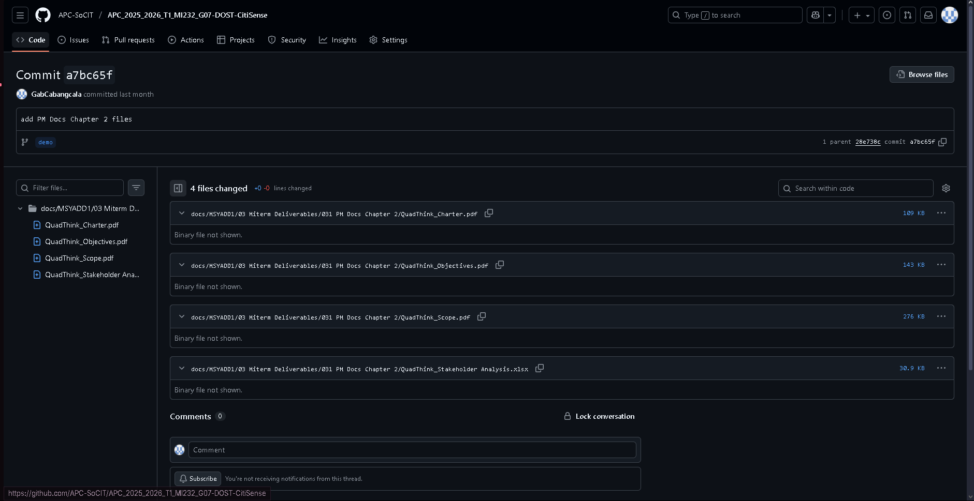
Dataflow Diagrams: Level 0 Context Diagram |Link|
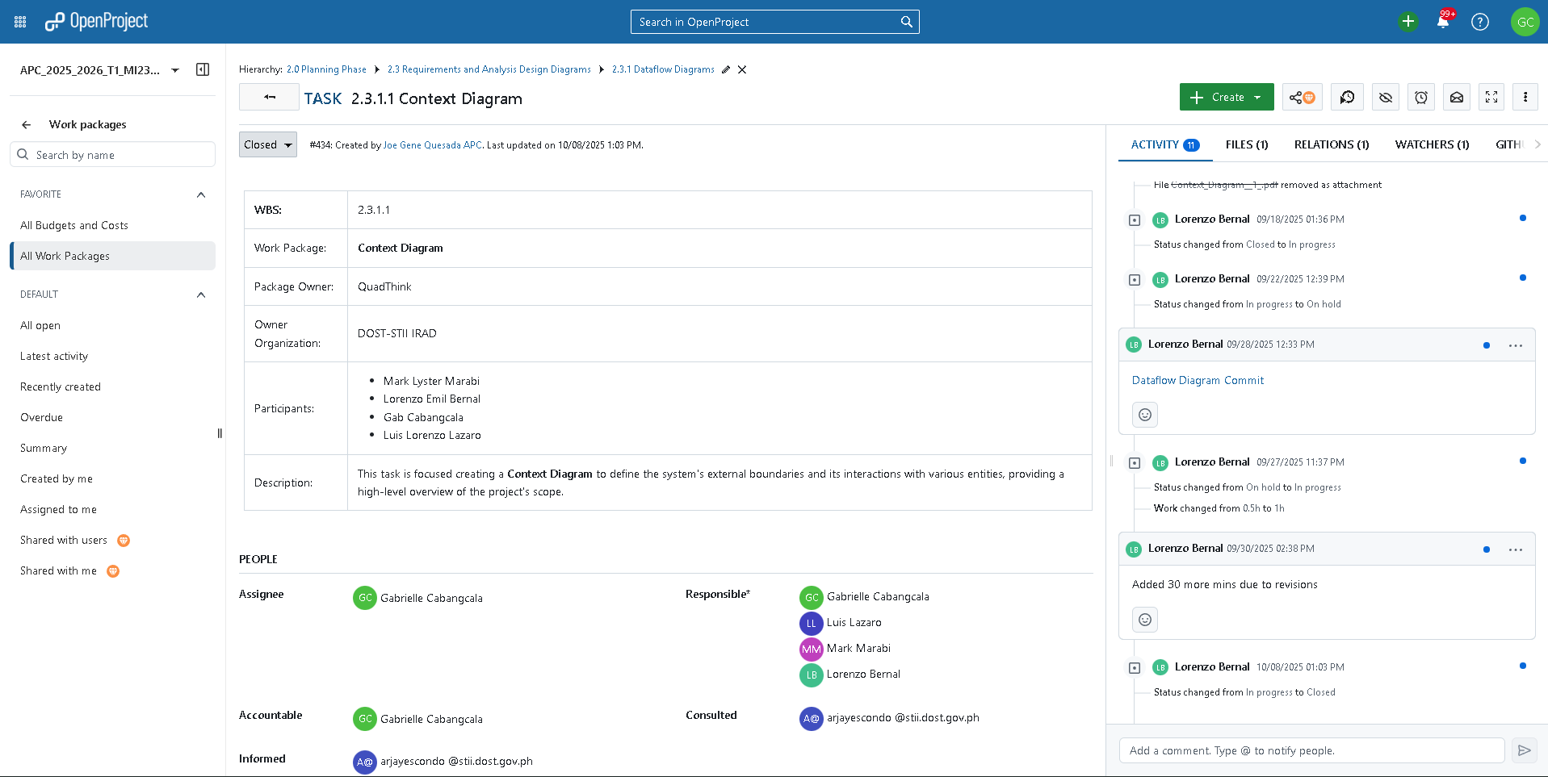
Corresponding Github repository commit |Link|
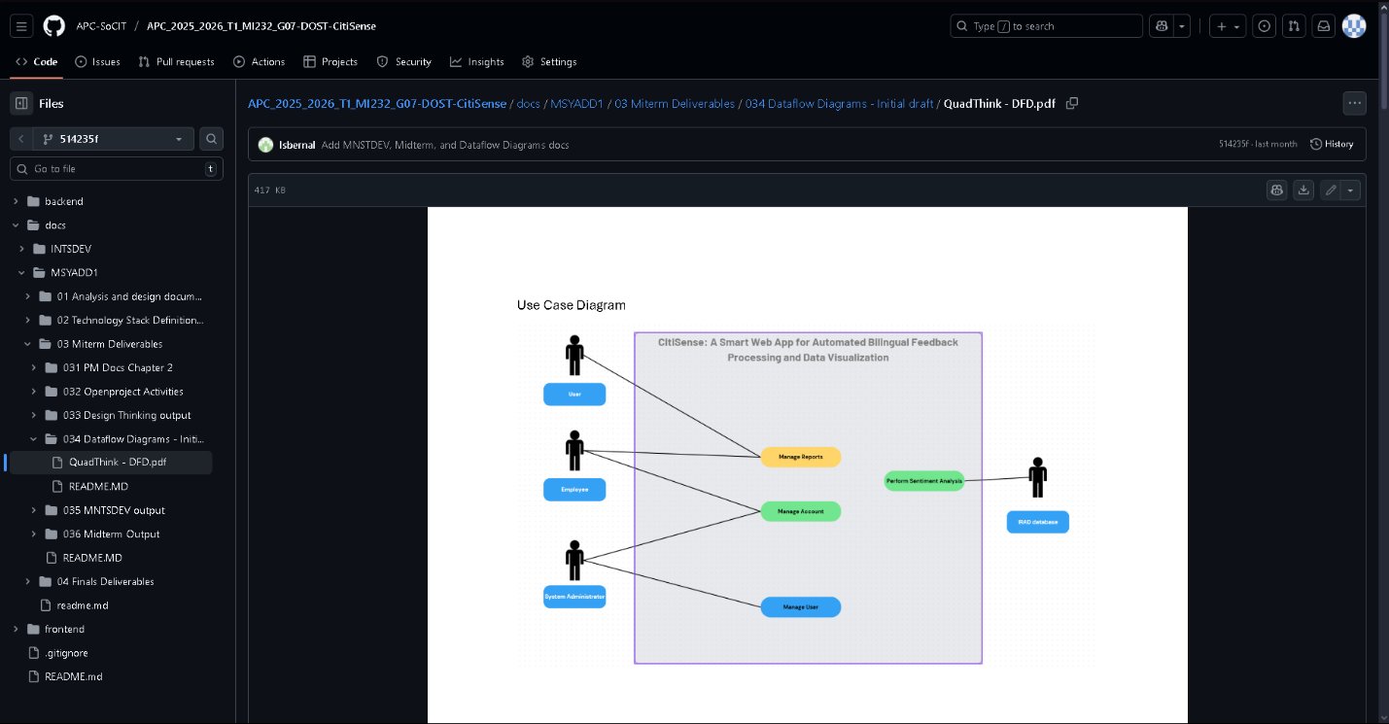
Dataflow Diagrams |Link|
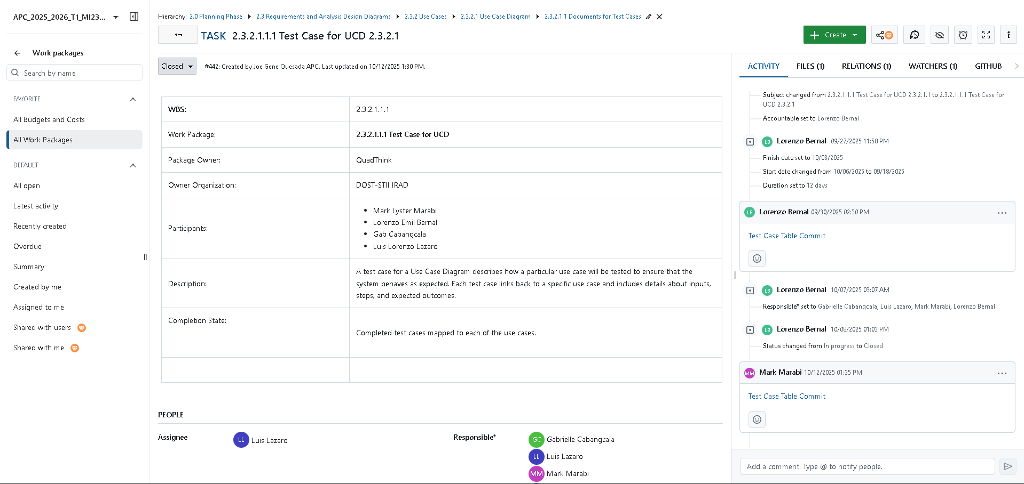
Corresponding Github repository commit |Link|

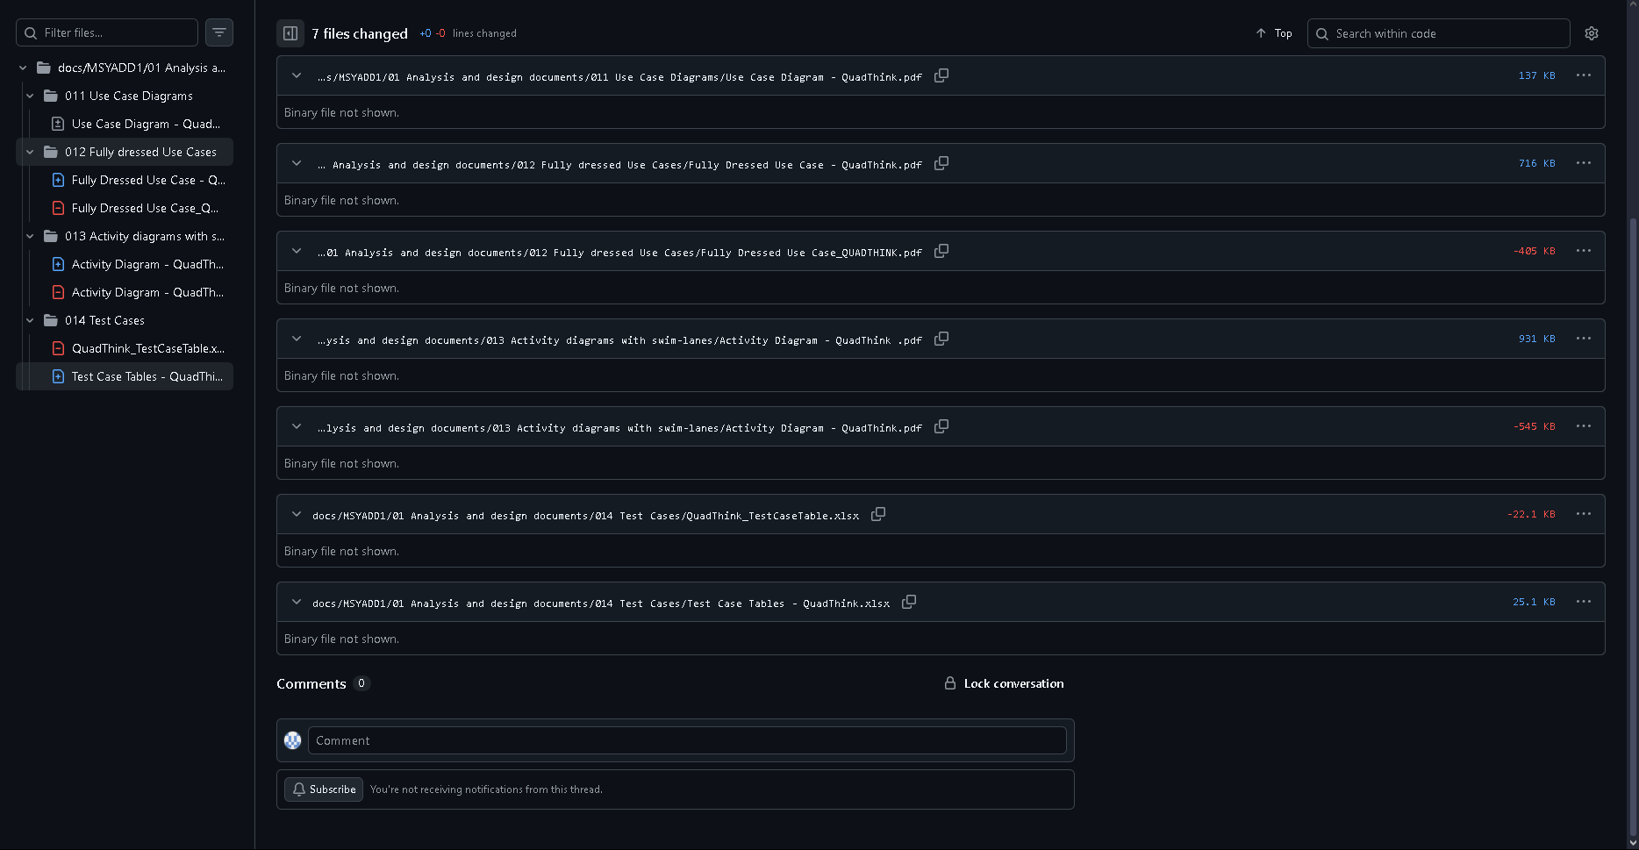

Activity Diagram with Swimlanes |Link|
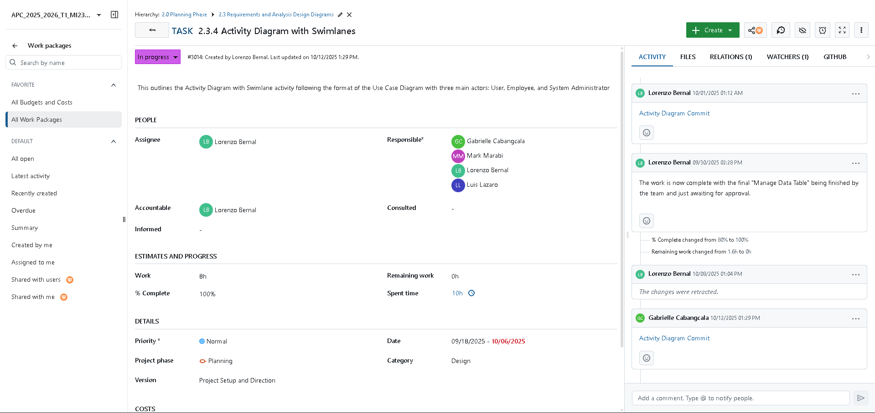
Corresponding Github repository commit |Link|
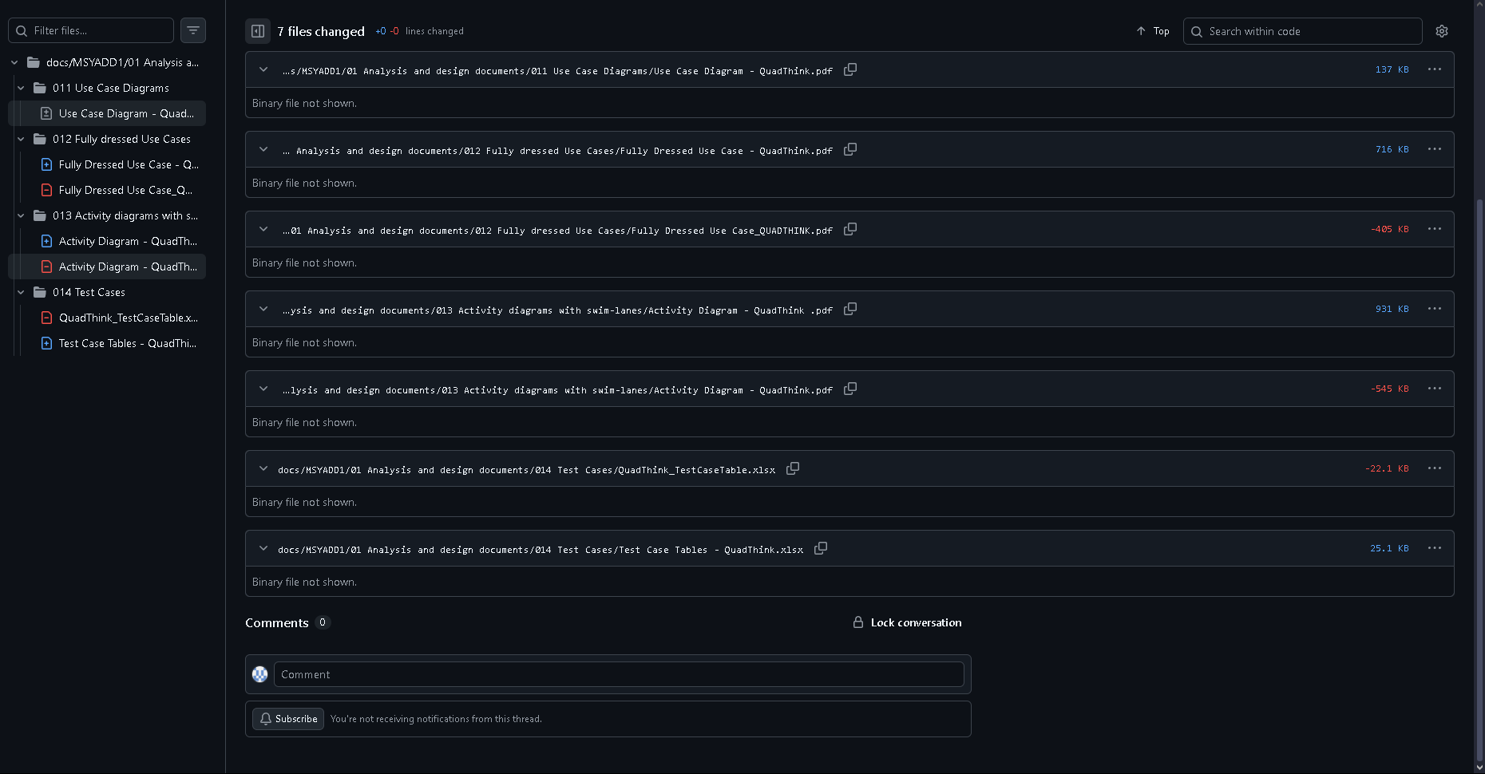

Entity Relationship Diagrams |Link|

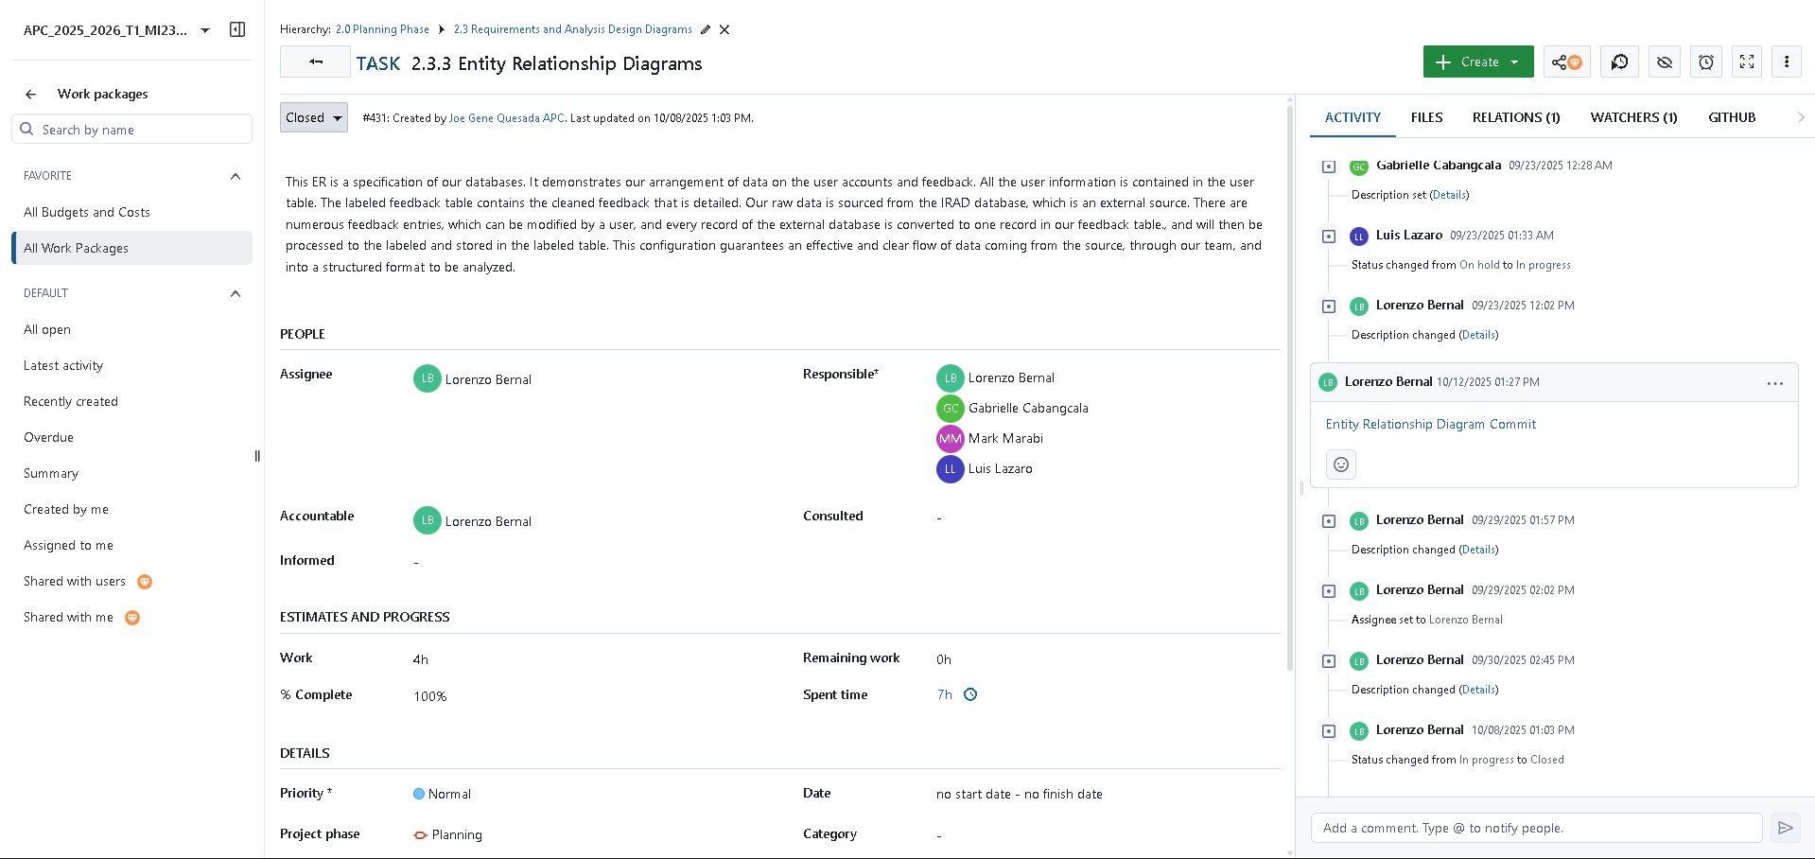
Corresponding Github repository commit |Link|

- Luis Lorenzo Lazaro
Project Charter |Link|
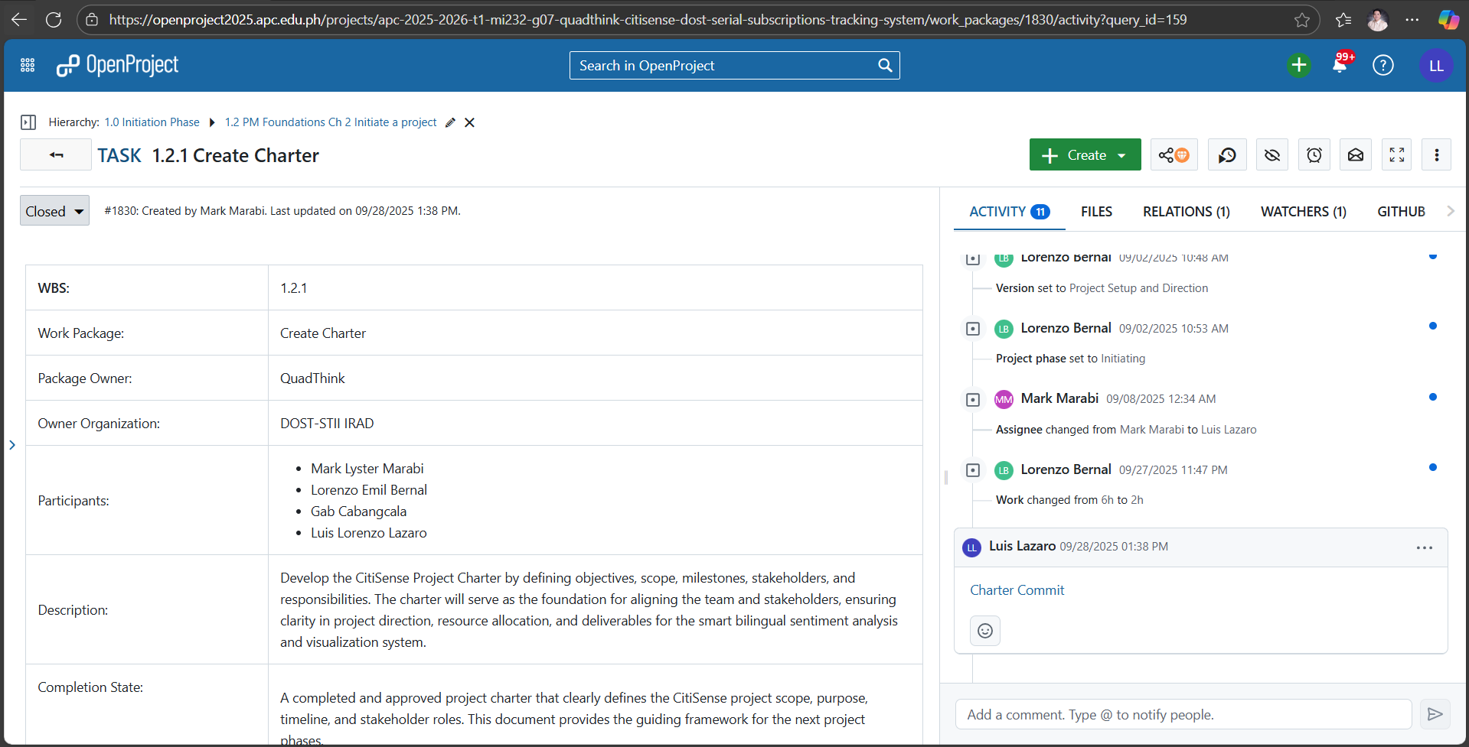

Corresponding Github repository commit |Link|
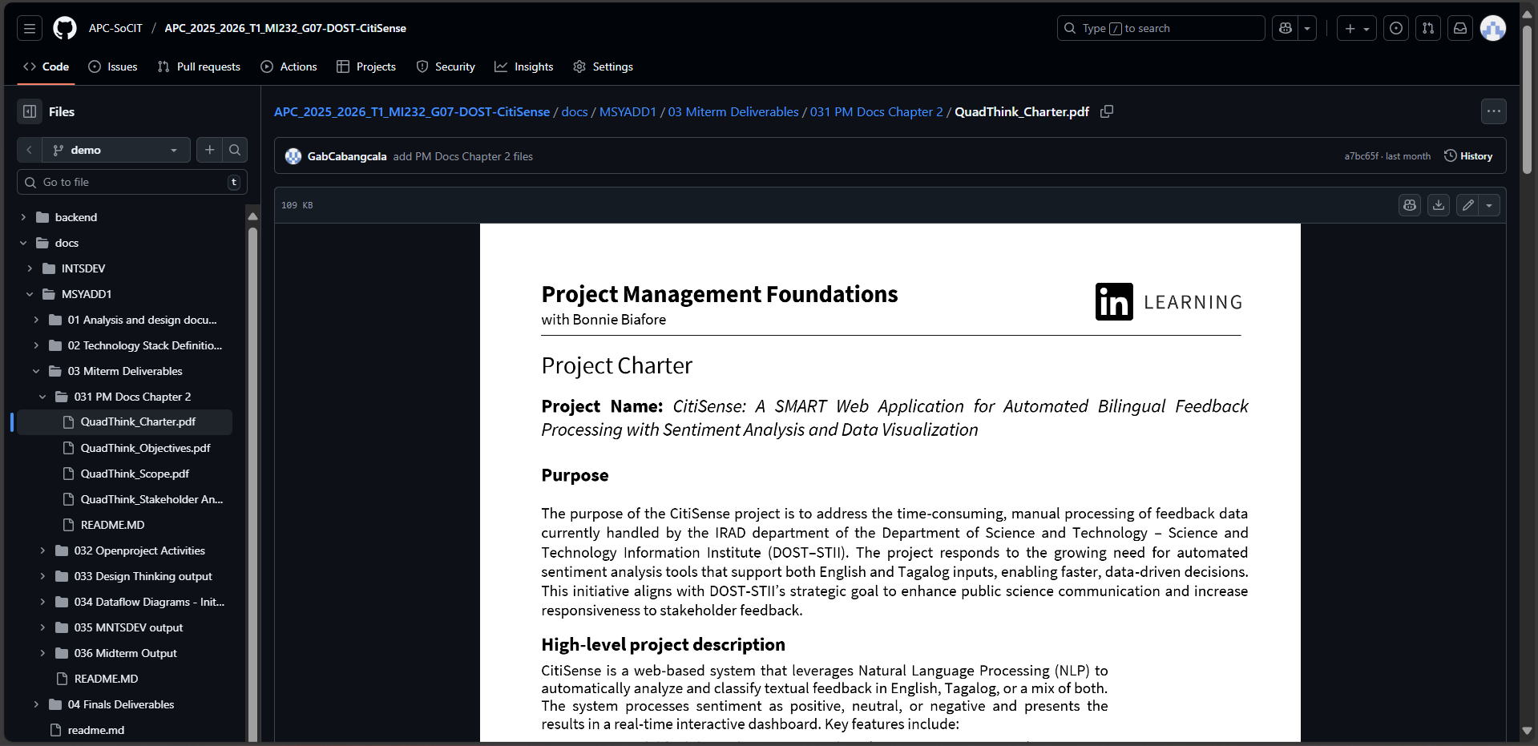

Fully Dressed Use Case |Link|
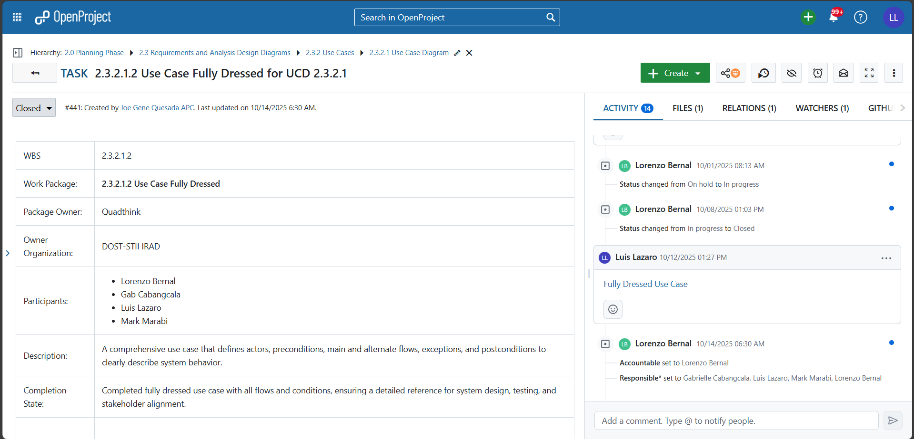

Corresponding Github repository commit |Link|
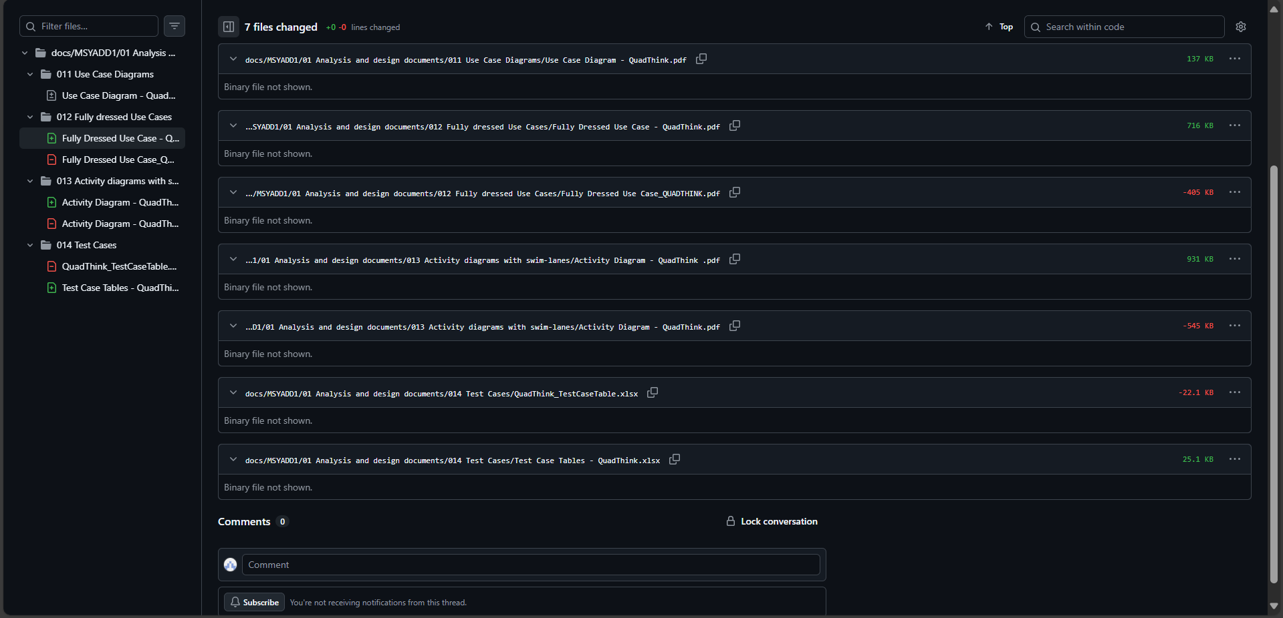

Test Case Tables |Link|
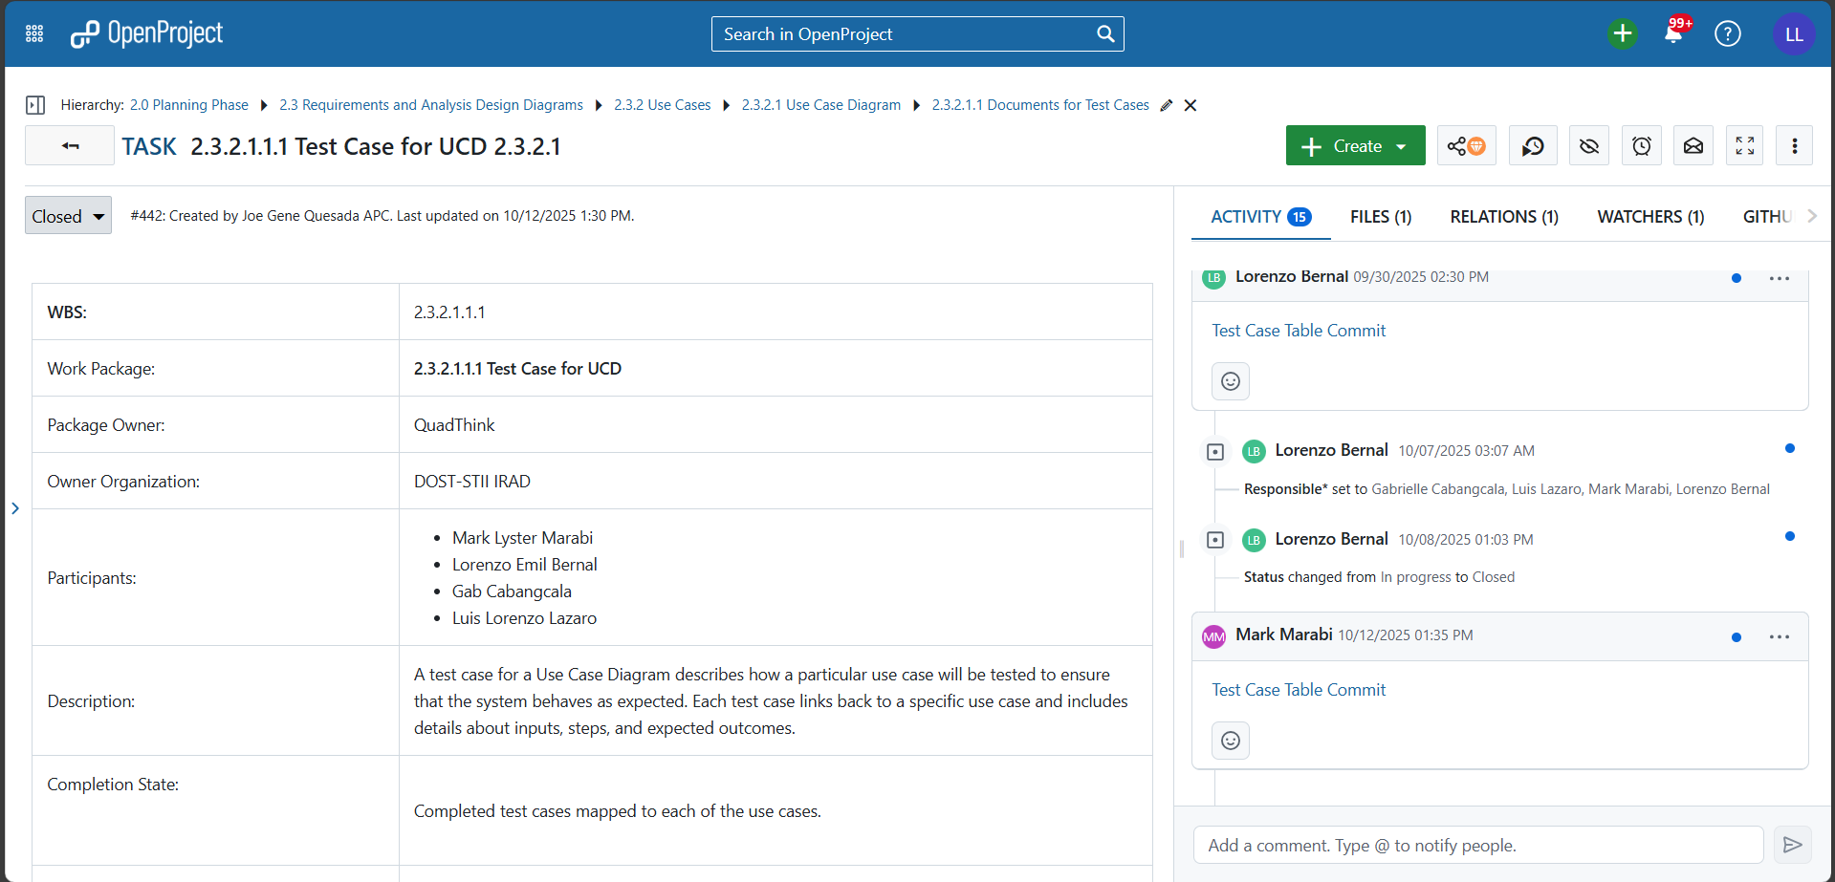

Corresponding Github repository commit |Link|
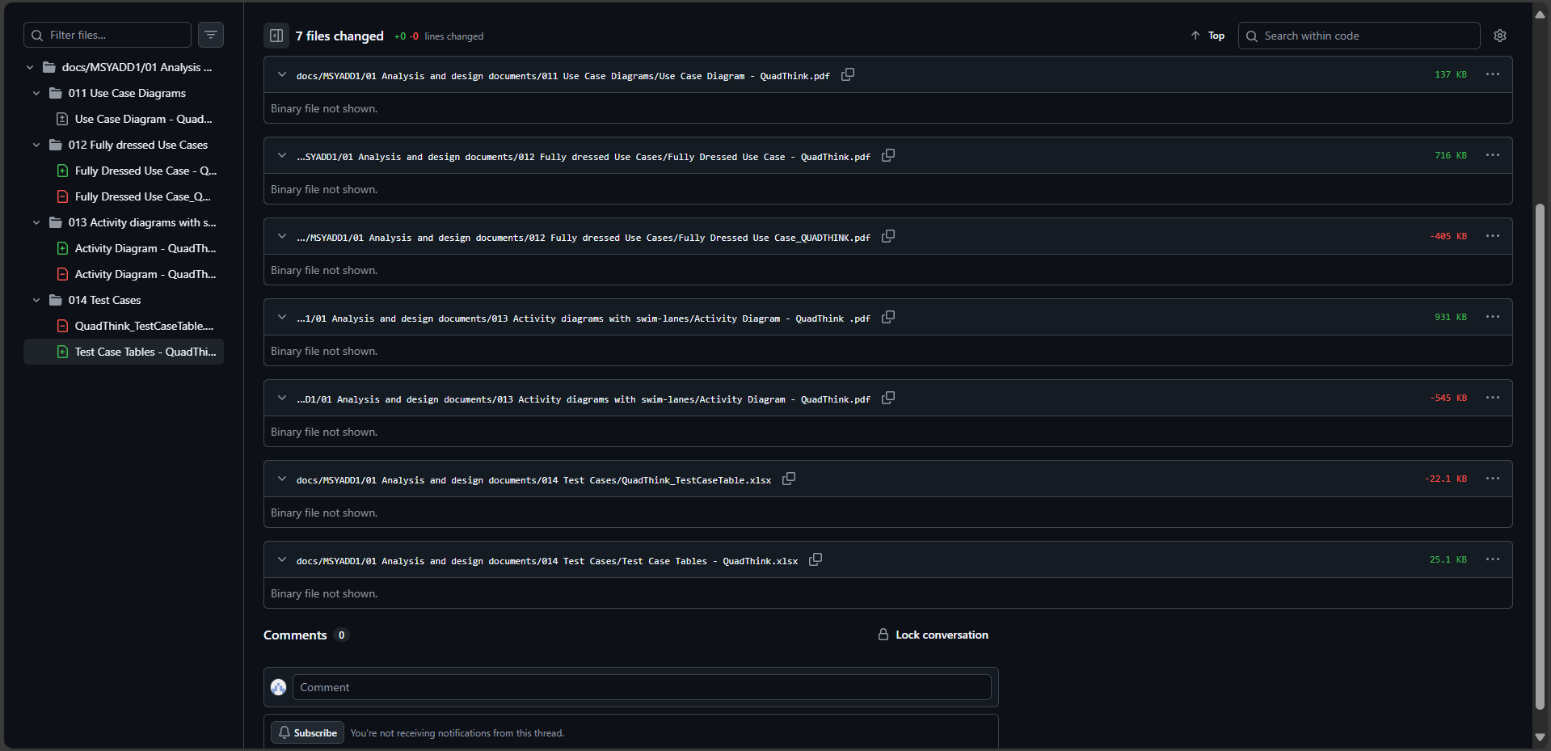

Activity Diagram with Swimlanes |Link|
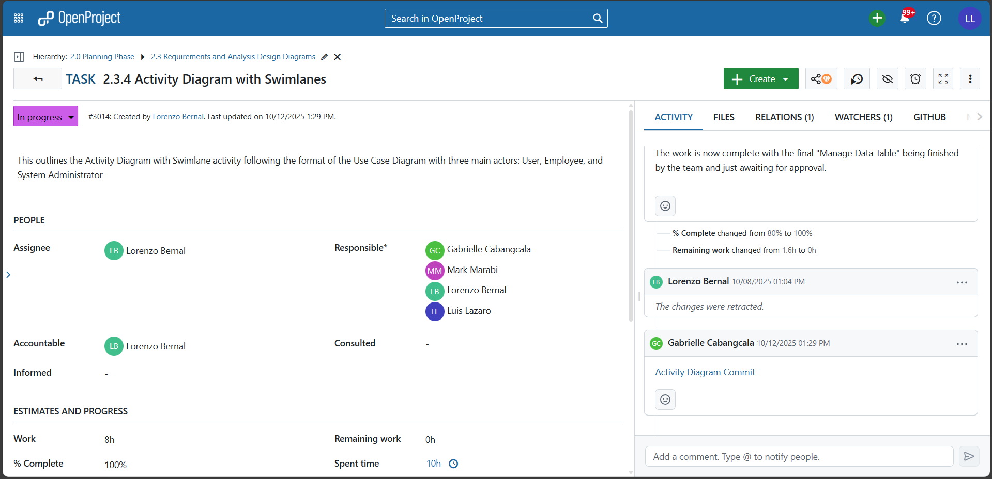

Corresponding Github repository commit |Link|
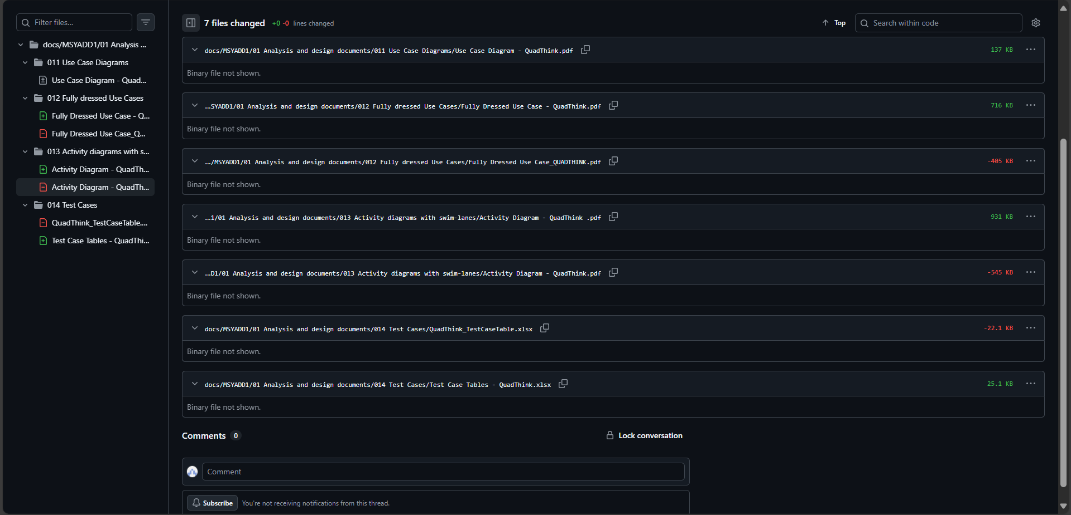

Dataflow Diagram Level 2: 1.0 - Manage Account |Link|
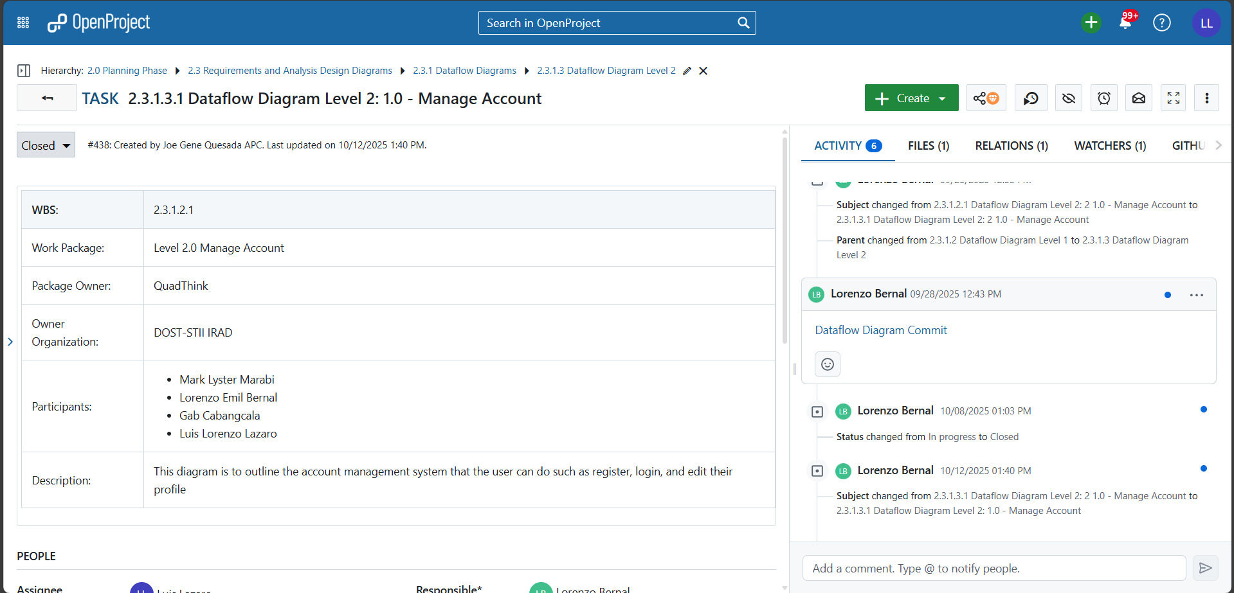

Corresponding Github repository commit |Link|
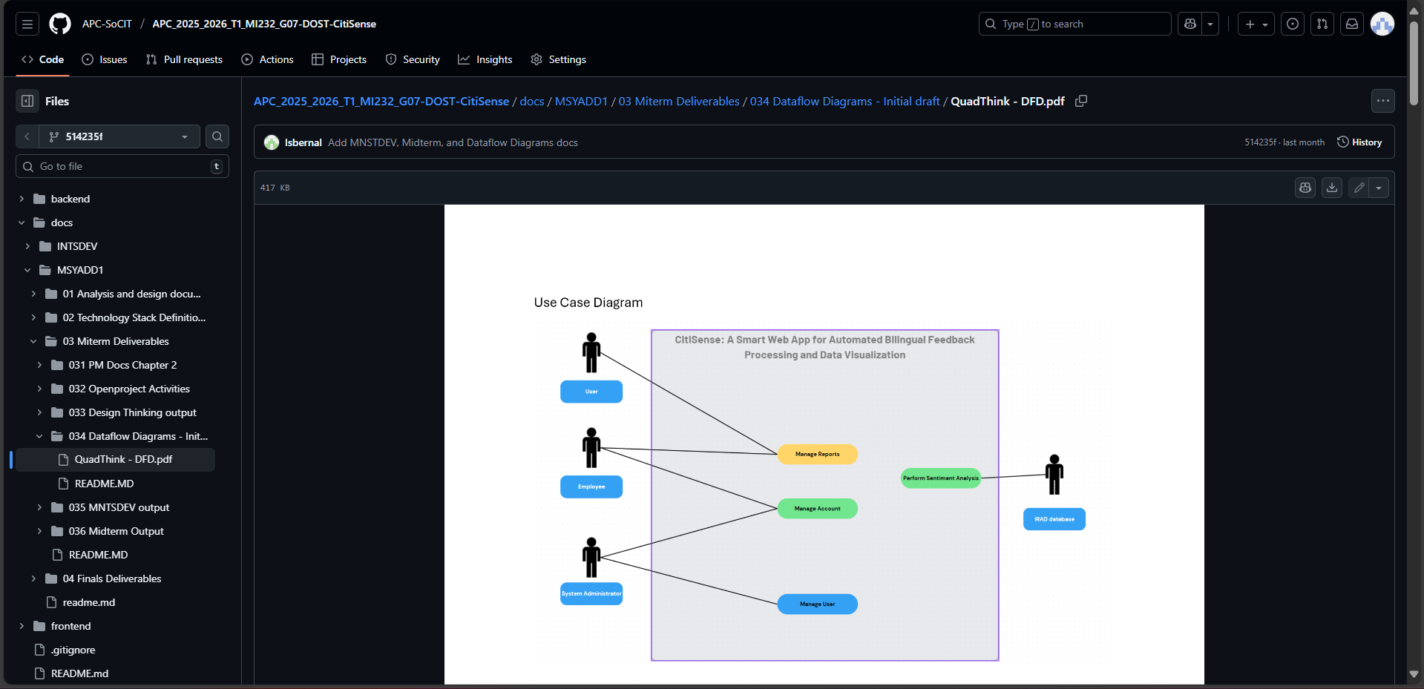

- Mark Lyster Marabi

Design Thinking Stage 2: Define |Link|
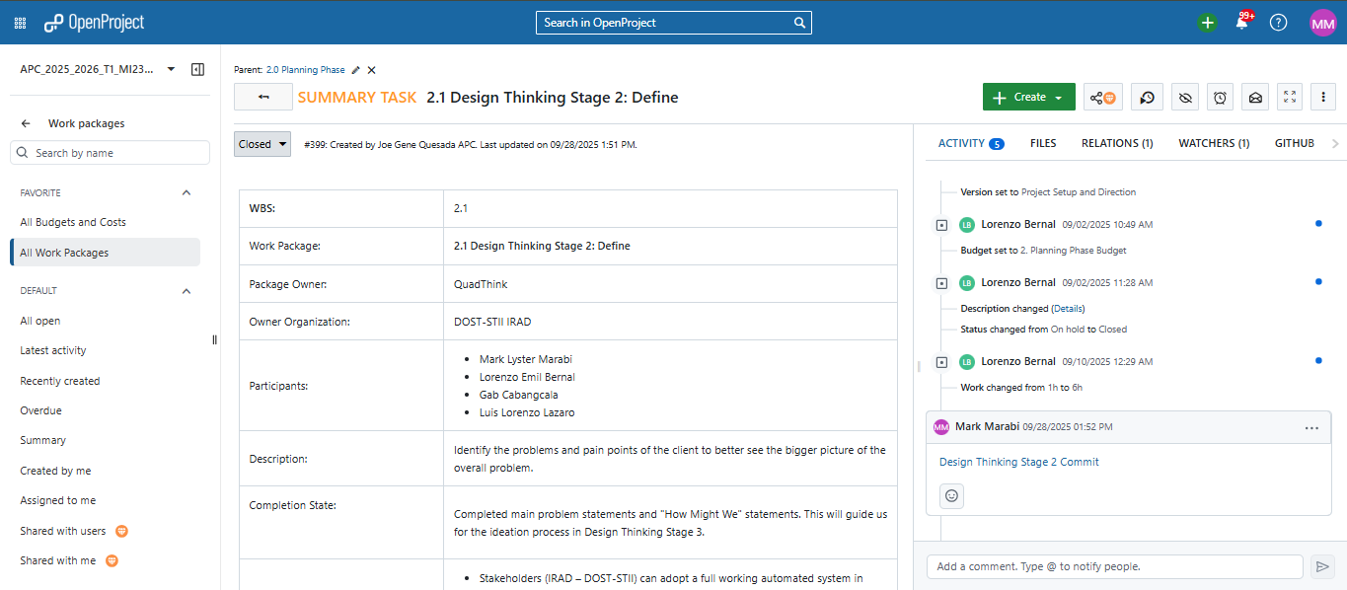

Corresponding Github repository commit |Link|
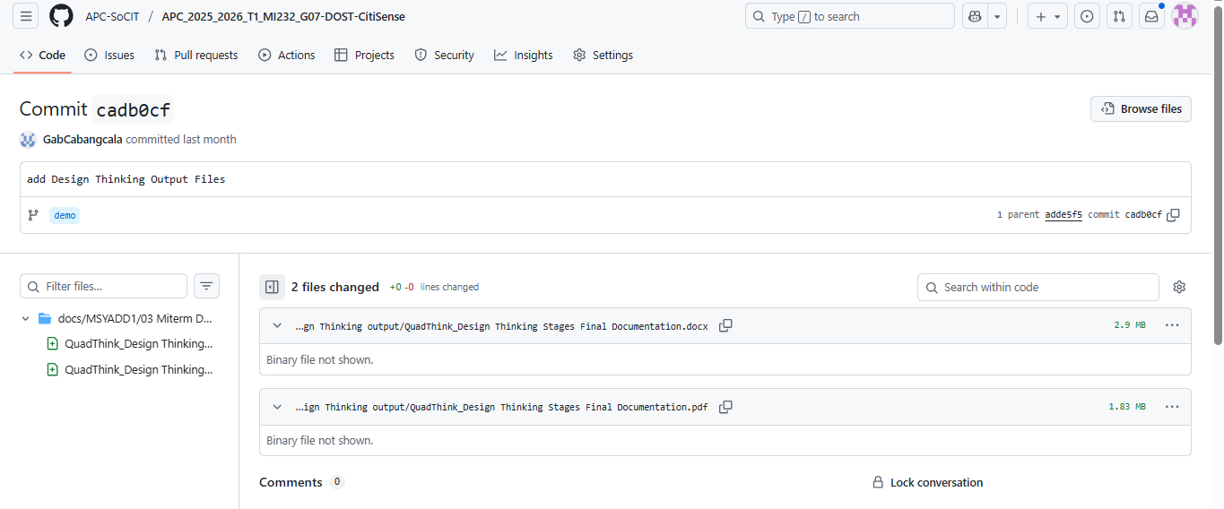

Test Case Tables |Link|


Test Case Tables repository commit |Link|
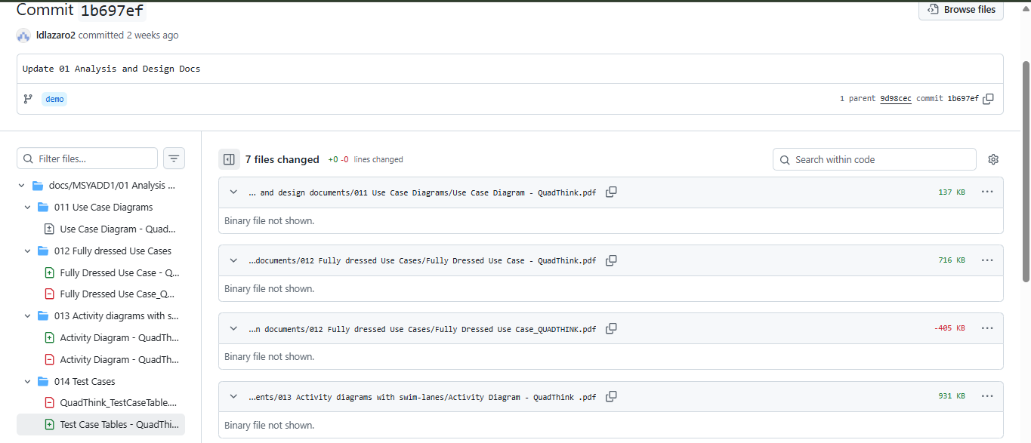

Activity Diagram with Swimlanes |Link|


Corresponding Github repository commit |Link|


